**MTA SECURITY FUNDAMENTALS**

**INTERNSHIP PROJECT**

**LIKITH.S**

**BMSCE**

**Part1**

**Note**

* The firewall on both the DC and RODC are disabled

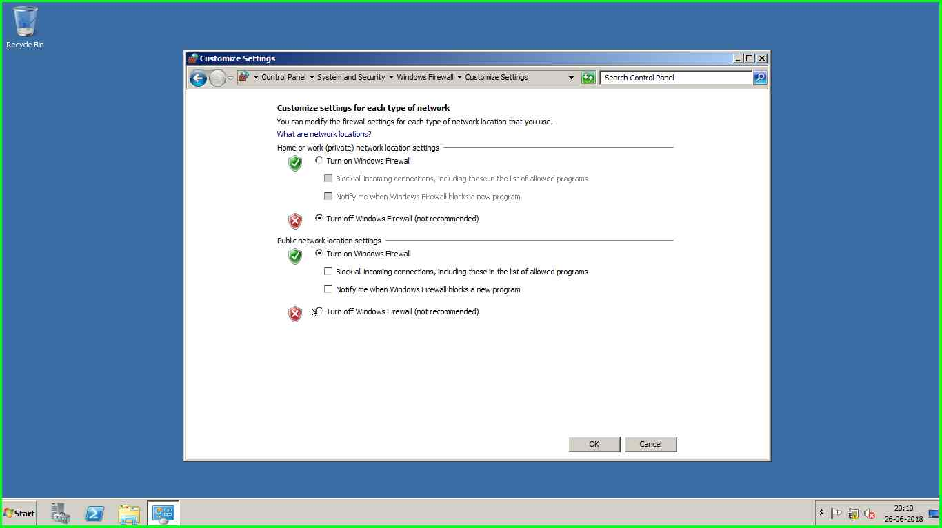

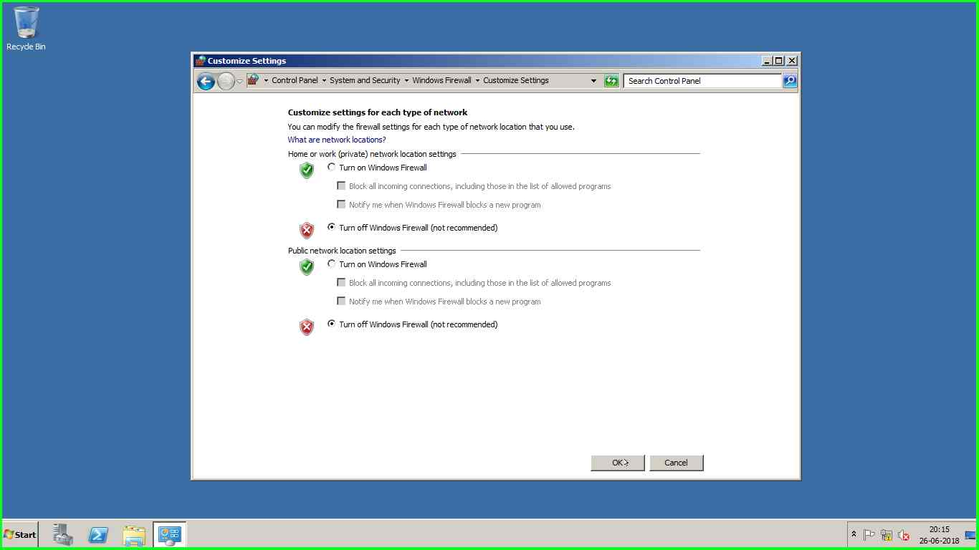

**1)** The network configuration is done as below

DC ip - 172.16.0.10 ; subnet mask- 255.255.255.0

ROD ip- 172.16.0.20 ; subnet mask- 255.255.255.0 ;preferred DNS -172.16.0.10

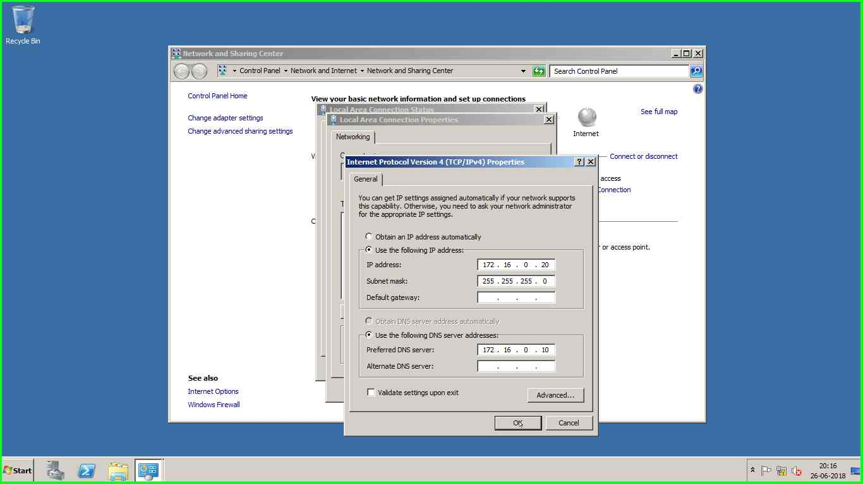

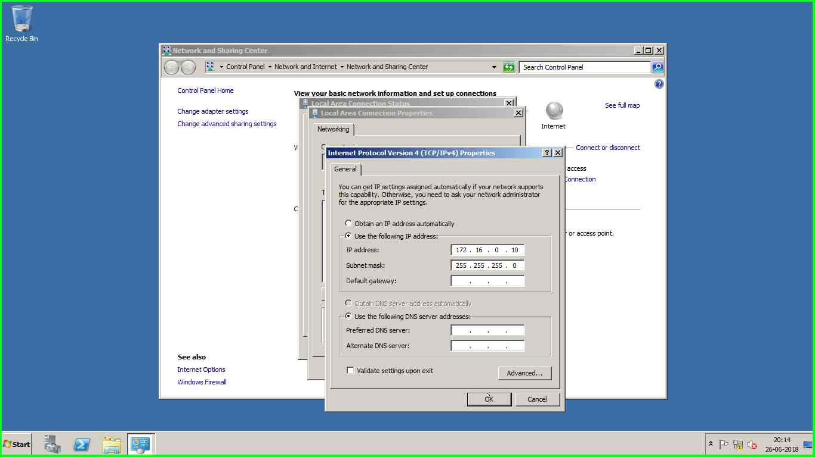

|  |
| --- |
|  |
|  |
|  |

Dc promo is run on the first VM to install the domain controller

[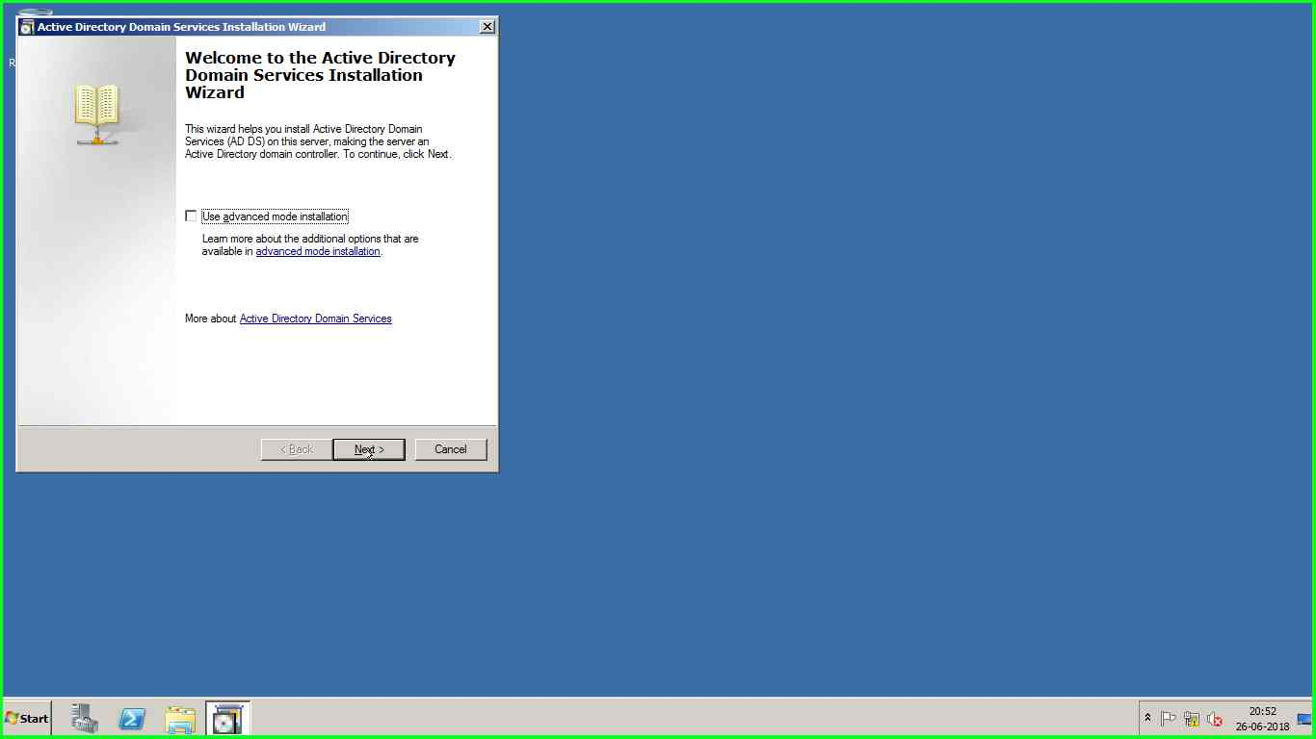](mhtml:file://C:\Users\Admin\AppData\Local\Temp\Rar$DIa5968.9666\Problem_20180626_2116.mht!screenshot_0013.jpeg)

[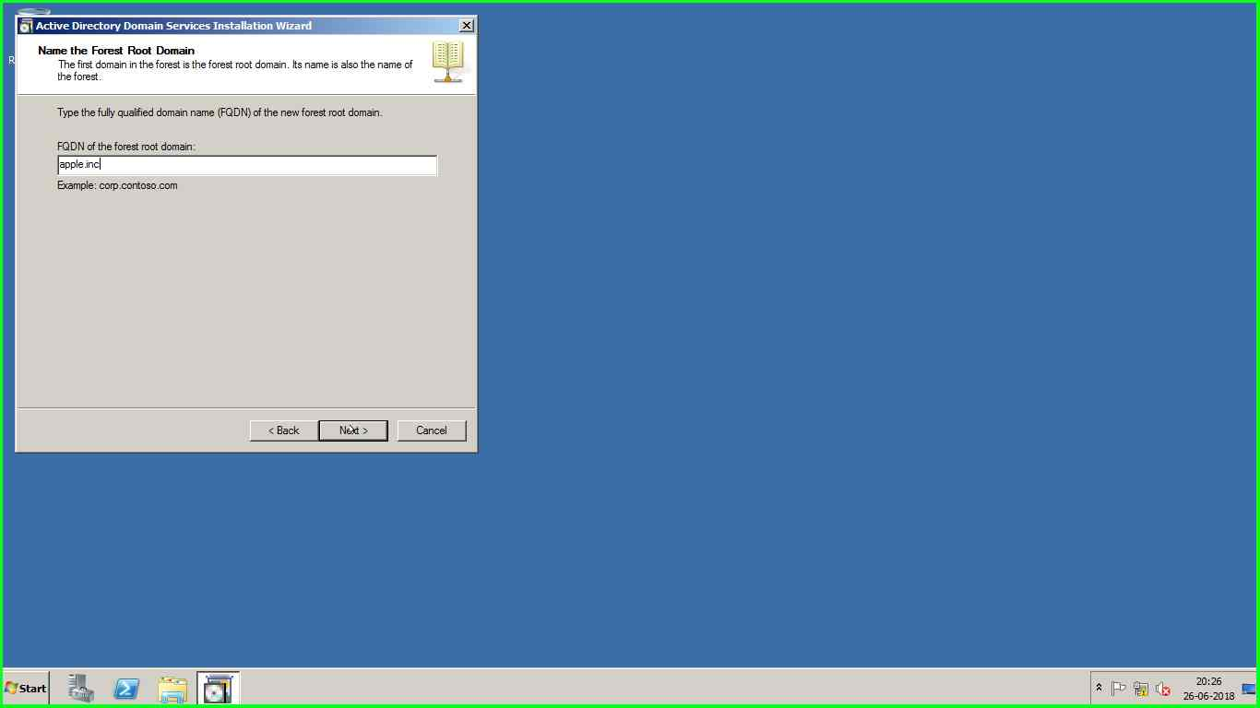](mhtml:file://C:\Users\Admin\AppData\Local\Temp\Rar$DIa5132.34627\Problem_20180626_2030.mht!screenshot_0007.jpeg)

[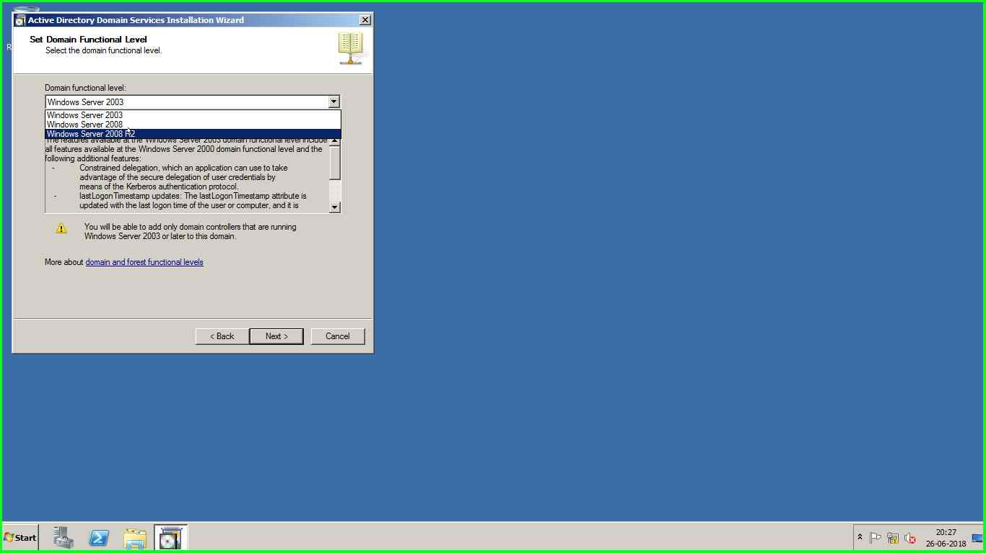](mhtml:file://C:\Users\Admin\AppData\Local\Temp\Rar$DIa5132.34627\Problem_20180626_2030.mht!screenshot_0010.jpeg)

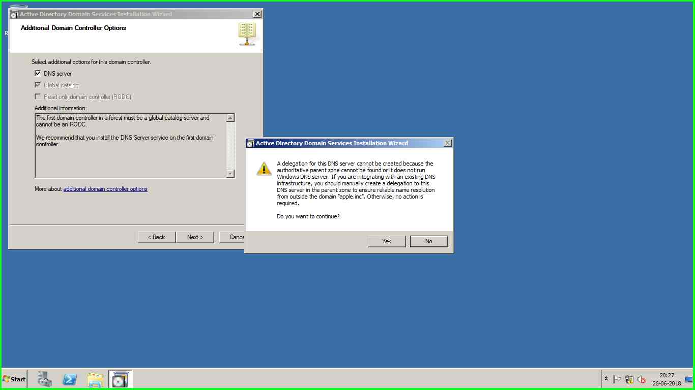

Dc promo is run on the second VM to install the read only domain controller

[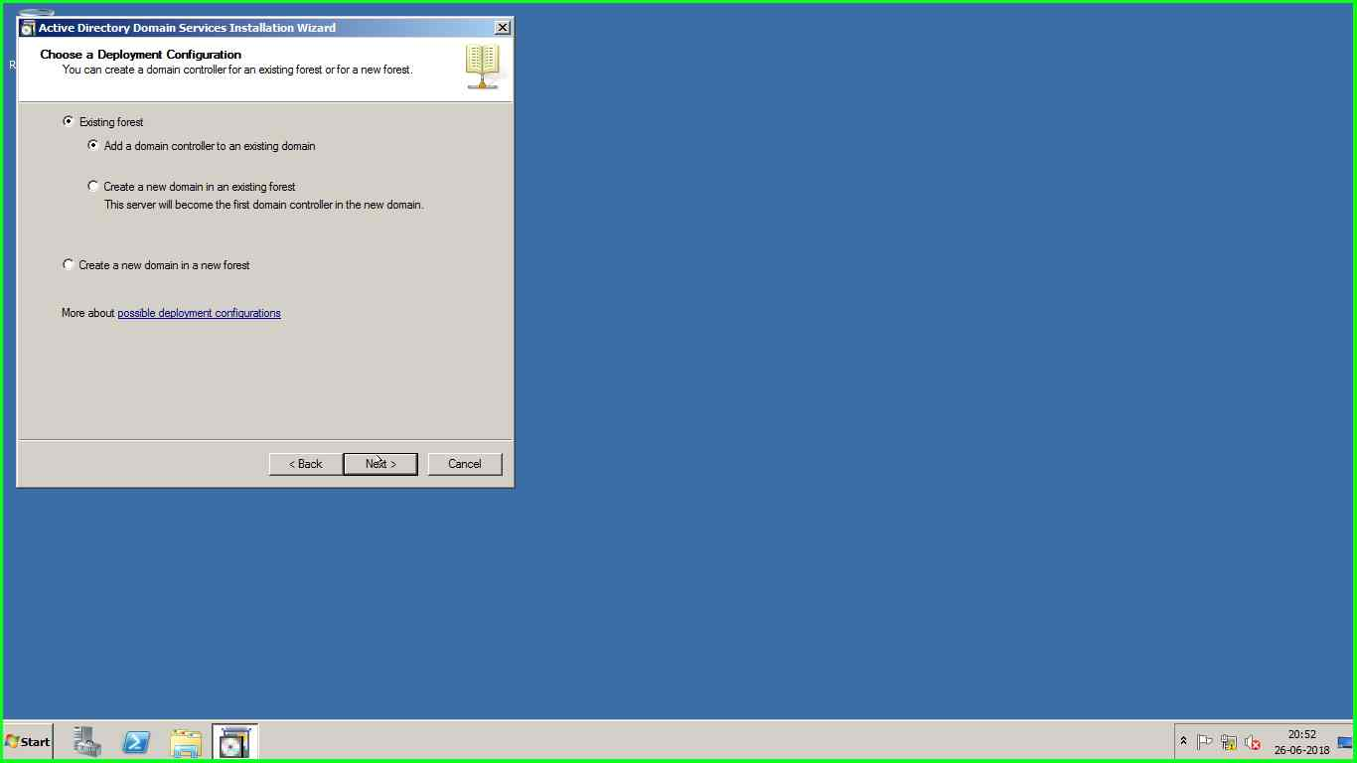](mhtml:file://C:\Users\Admin\AppData\Local\Temp\Rar$DIa5968.9666\Problem_20180626_2116.mht!screenshot_0016.jpeg)

[](mhtml:file://C:\Users\Admin\AppData\Local\Temp\Rar$DIa5968.9666\Problem_20180626_2116.mht!screenshot_0013.jpeg)

[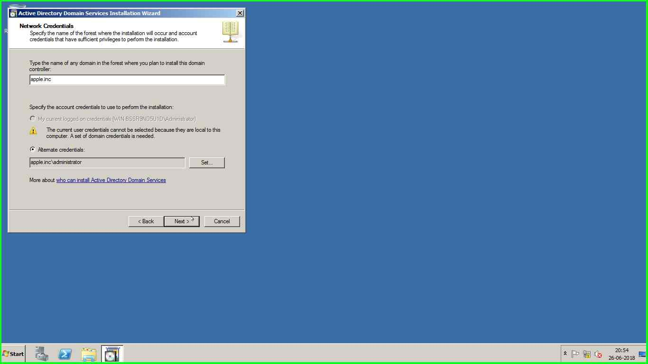](mhtml:file://C:\Users\Admin\AppData\Local\Temp\Rar$DIa5968.9666\Problem_20180626_2116.mht!screenshot_0023.jpeg)

[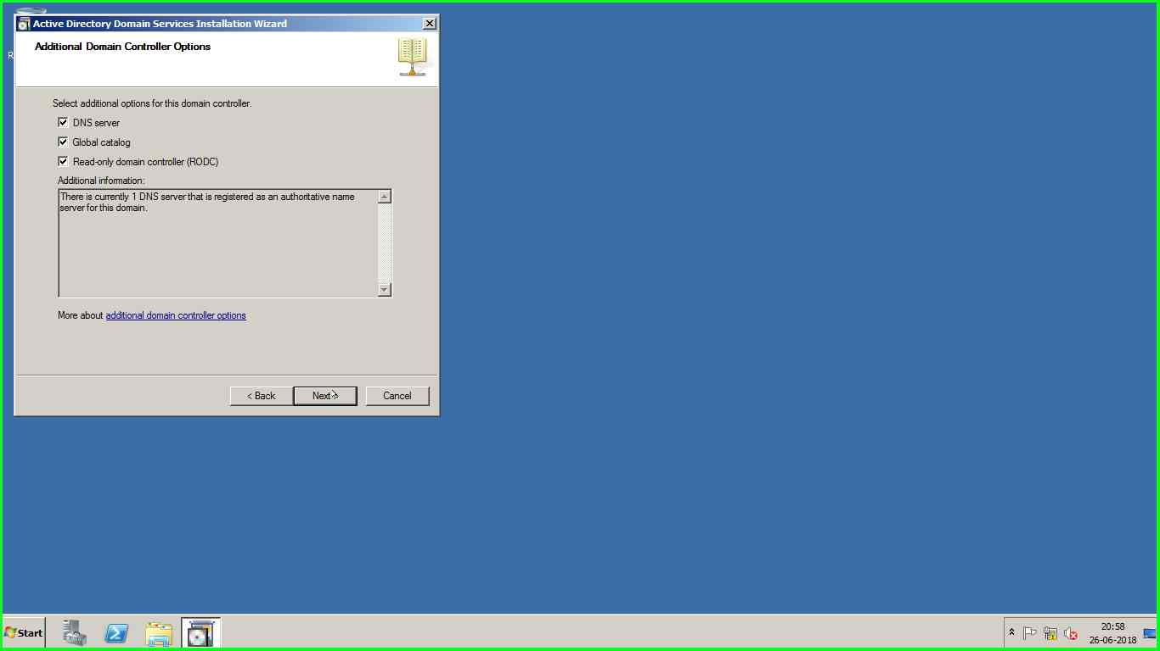](mhtml:file://C:\Users\Admin\AppData\Local\Temp\Rar$DIa5968.9666\Problem_20180626_2116.mht!screenshot_0027.jpeg)

3)E drive of 10gb is added and bitlocked

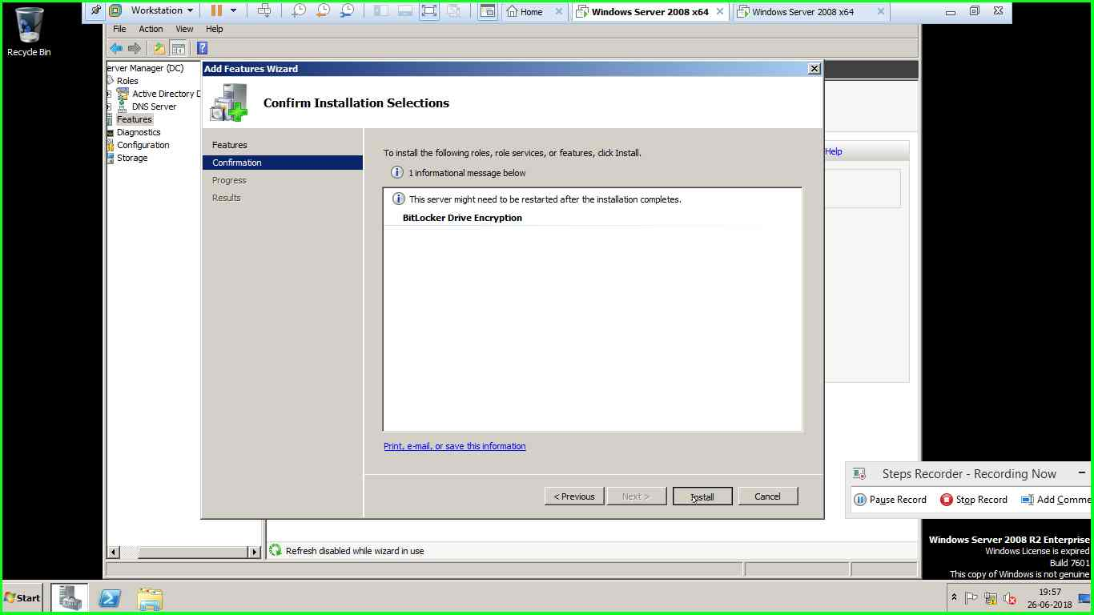

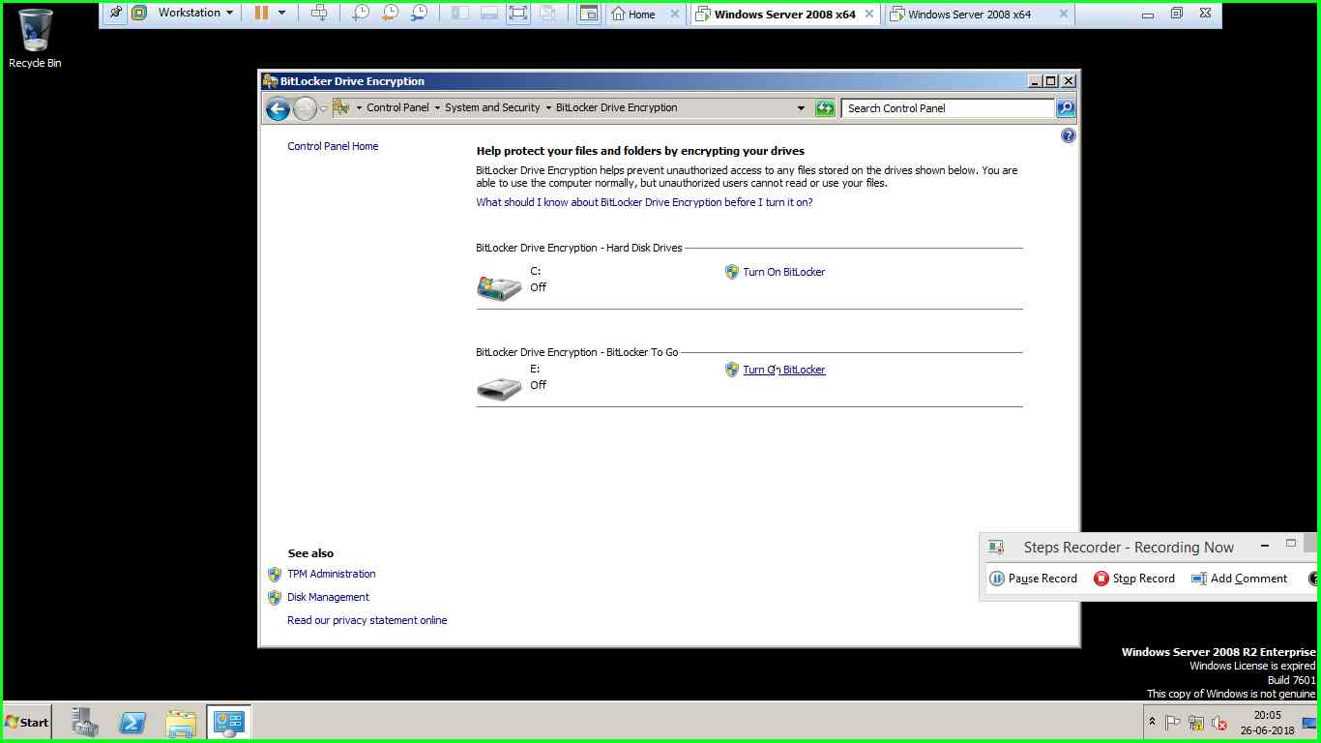

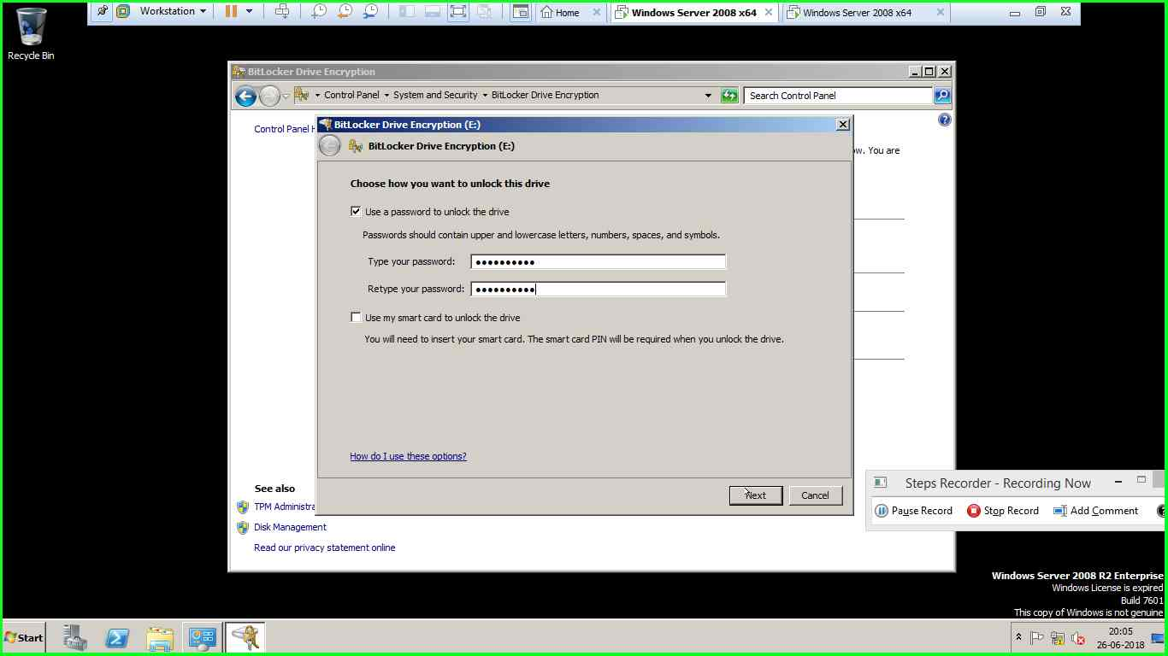

|  |
| --- |
|  |
|  |
|  |

4) 5 disks of 10gb are added

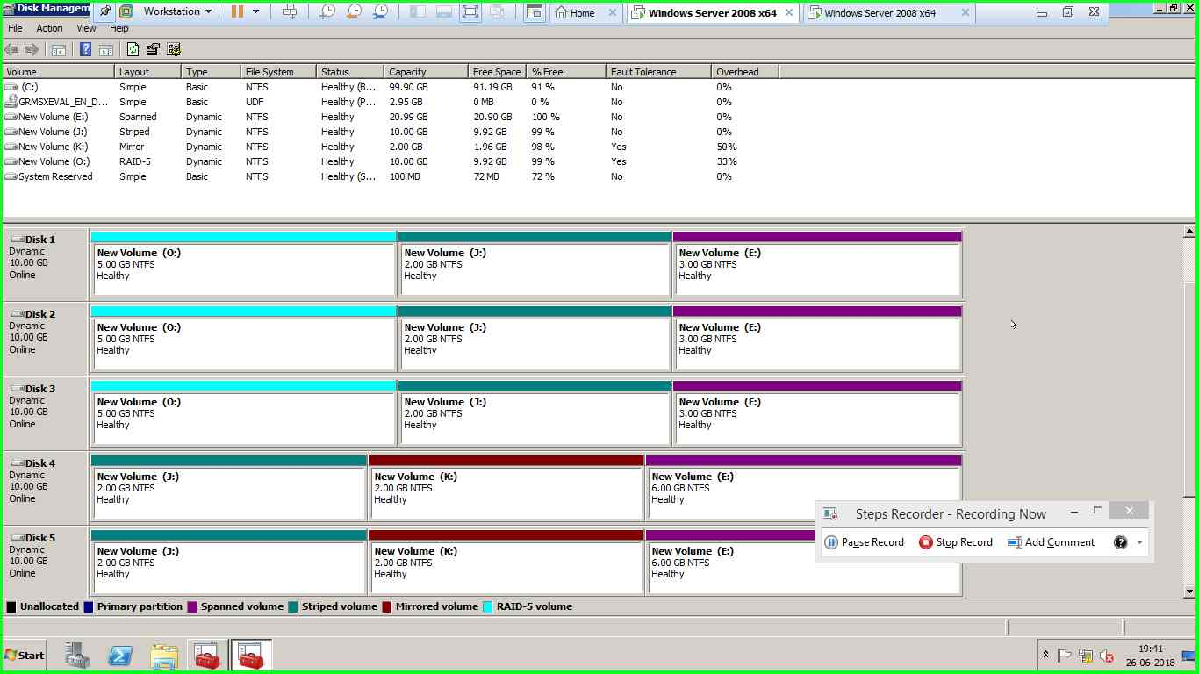

5)A raid 5 volume of 10 gb is created using 3 disks

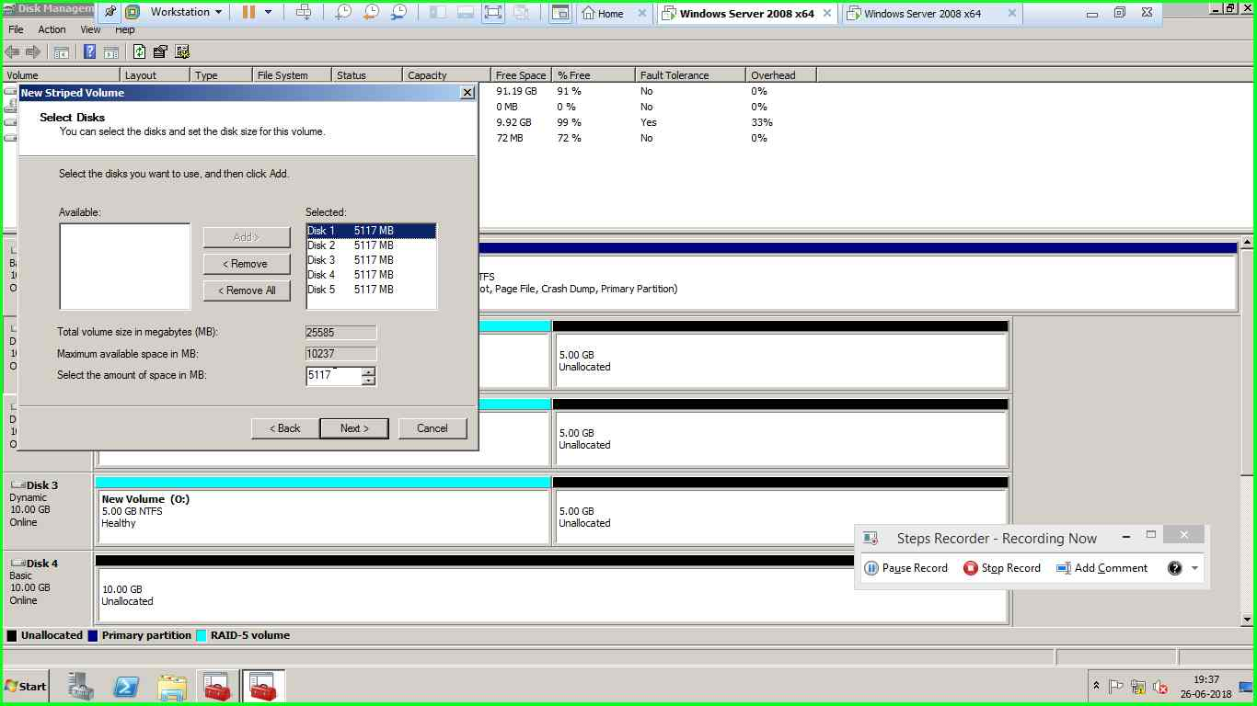

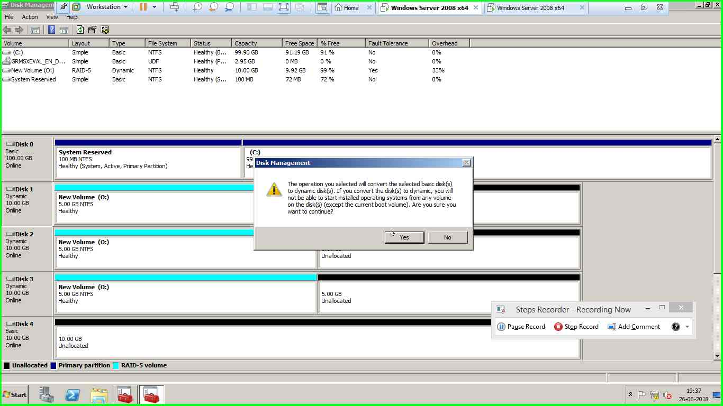

6) 1 mirror volume of 2gb size is created

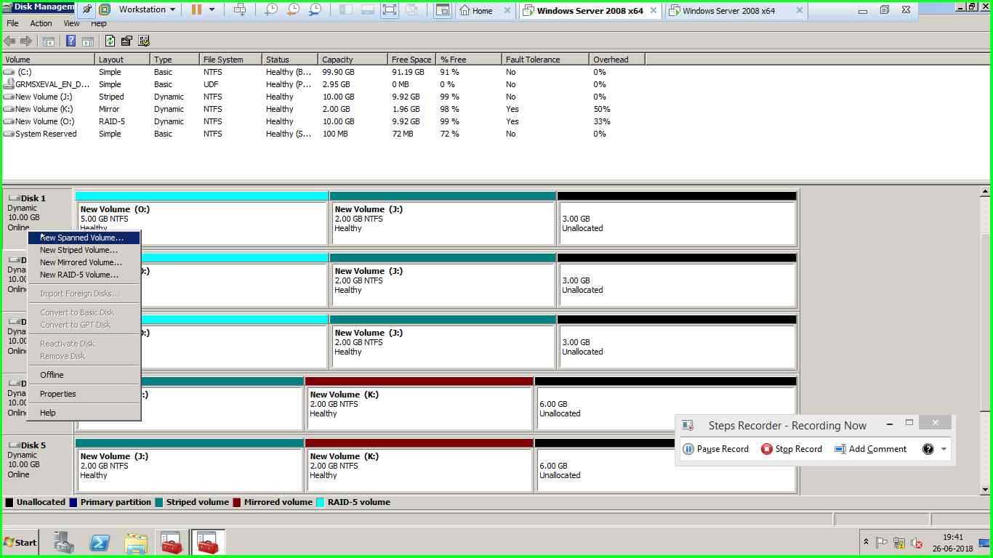

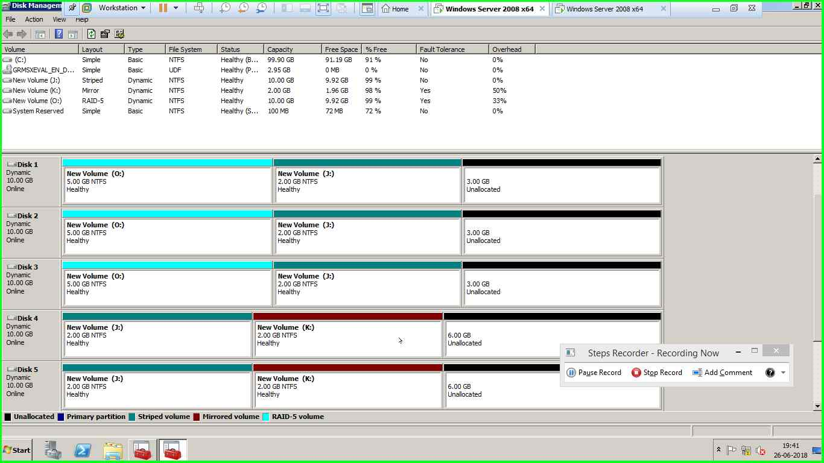

7) 1 striped volume is created from 5 disks taking 2gb each from disk

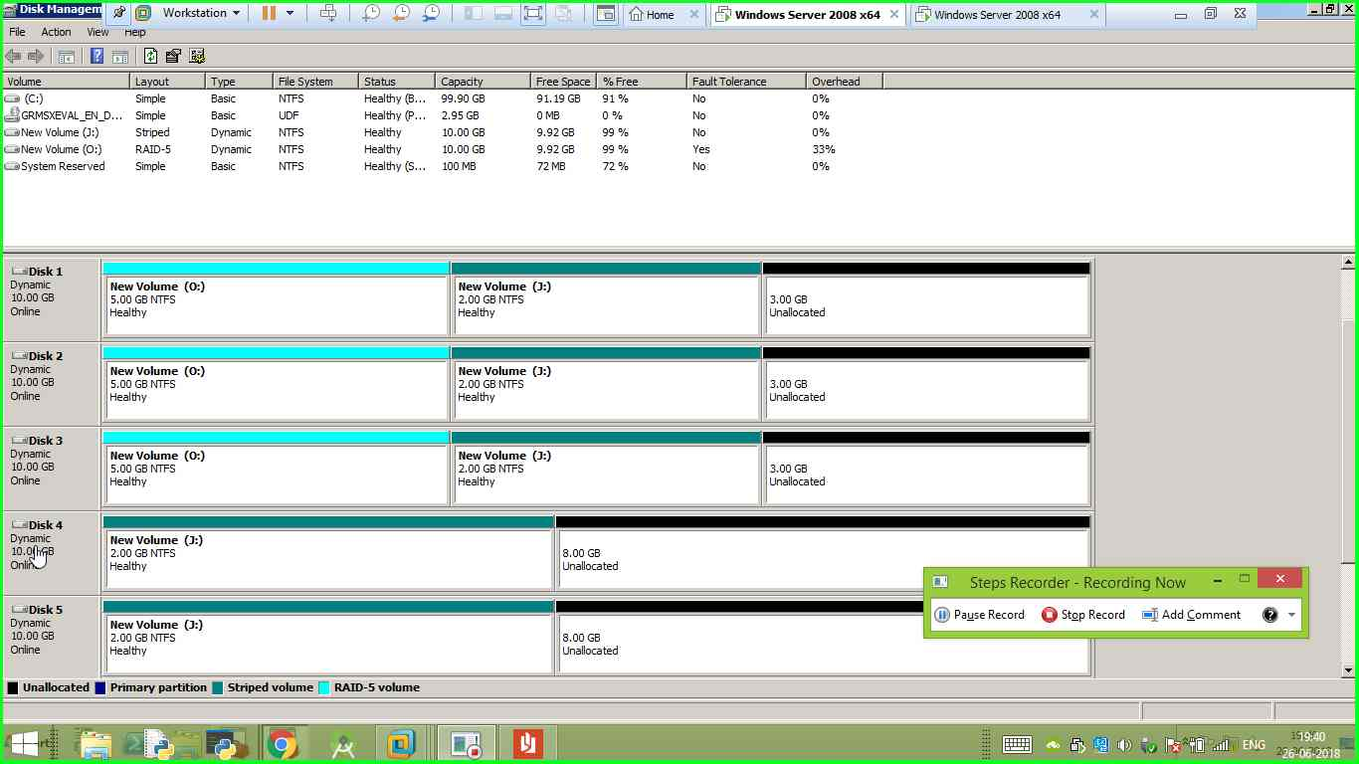

8)the rest space is used to create a spanned volume

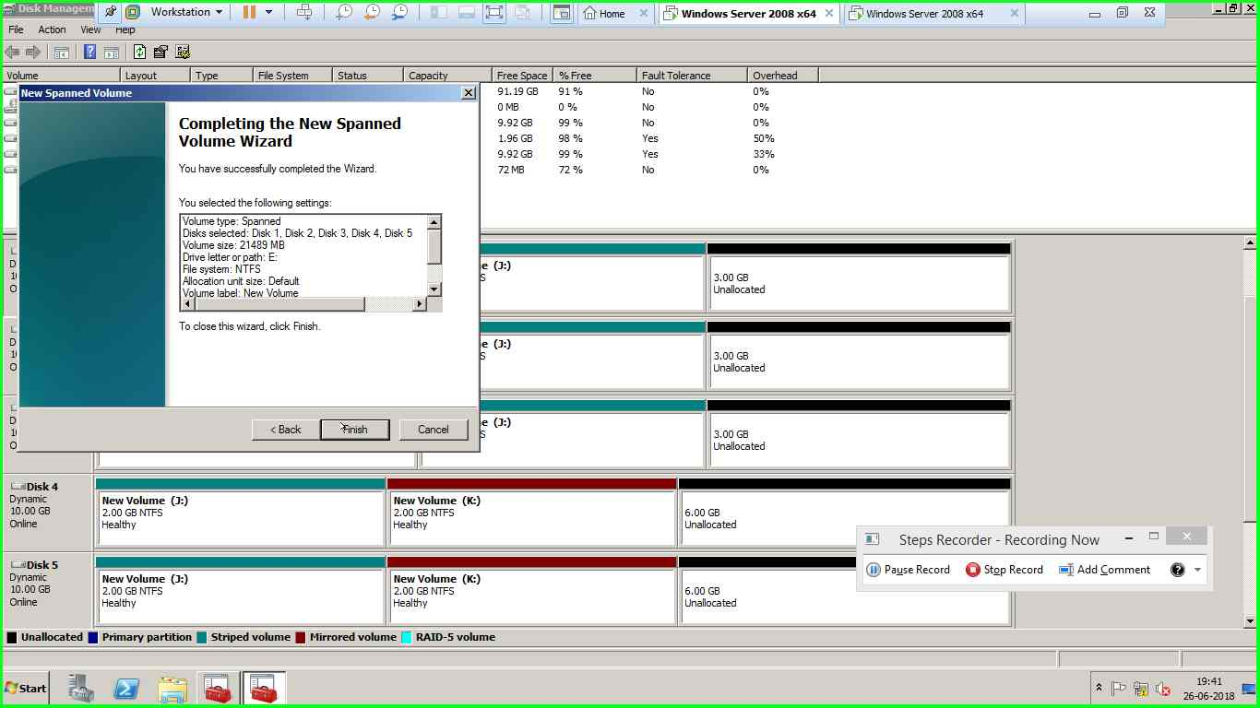



9)windows OU is created with 3 users and a child OU client has 3 users

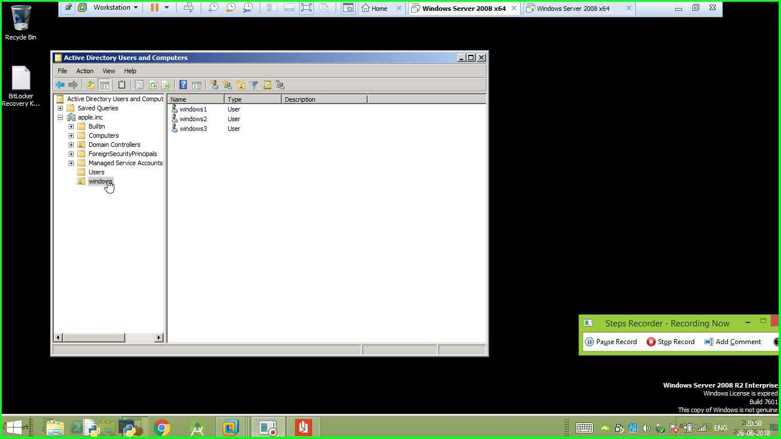

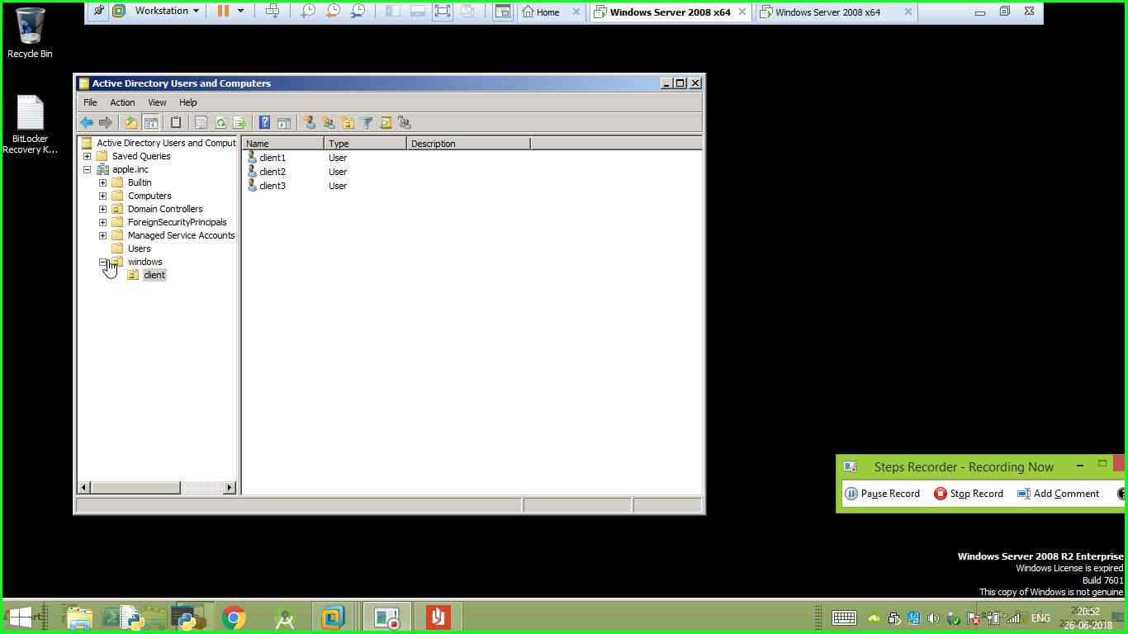

10)10 users are created by running the batch file

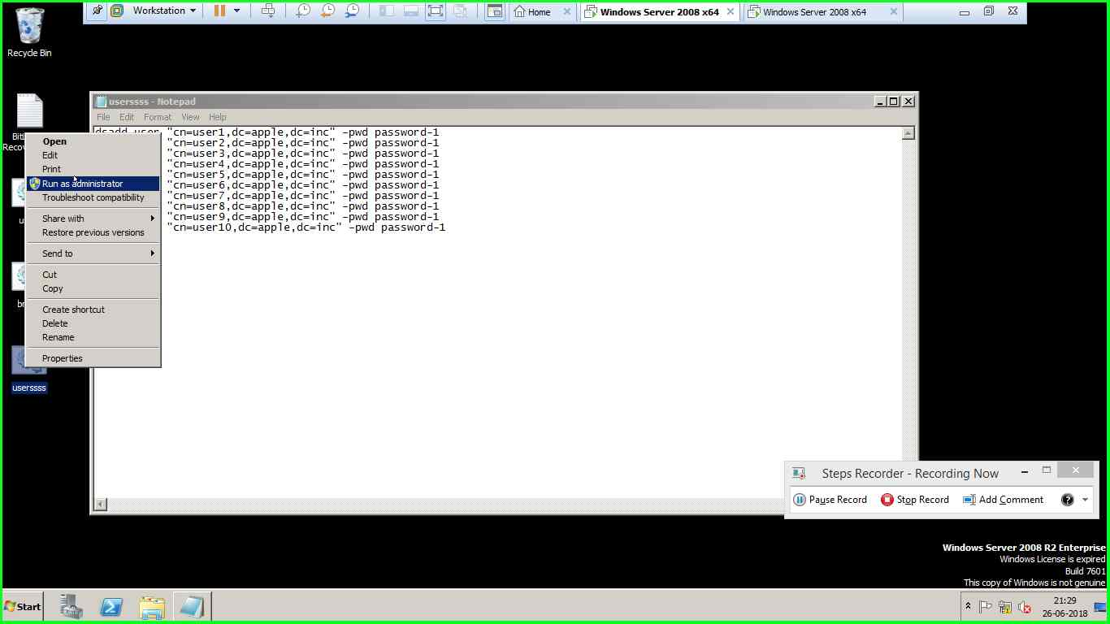

11)BMSCE and BMSIT OU’s have 5 users each

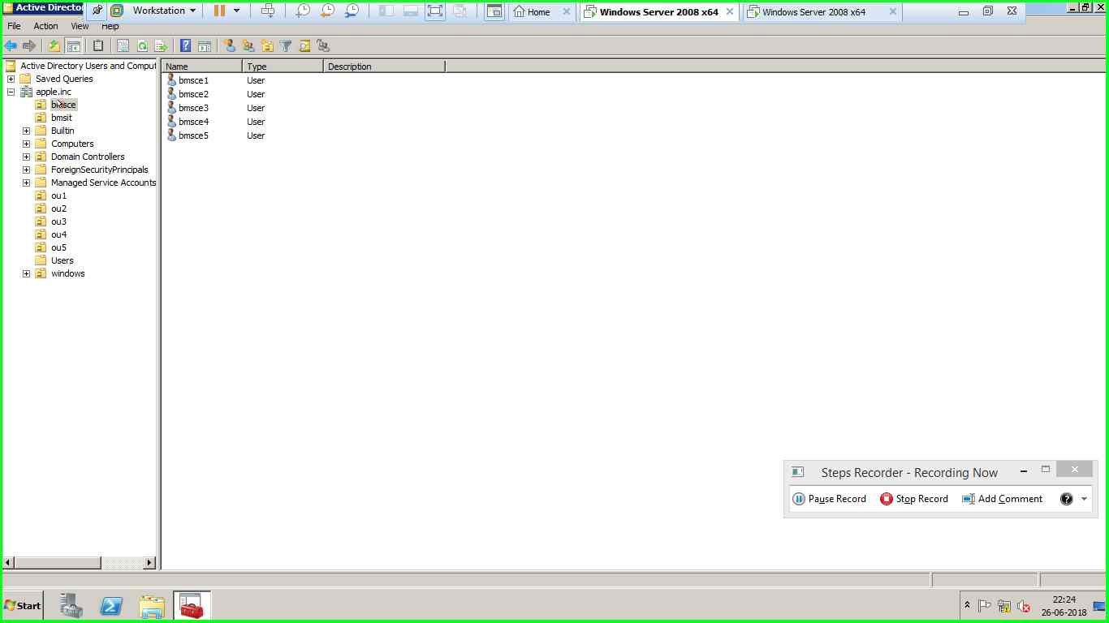

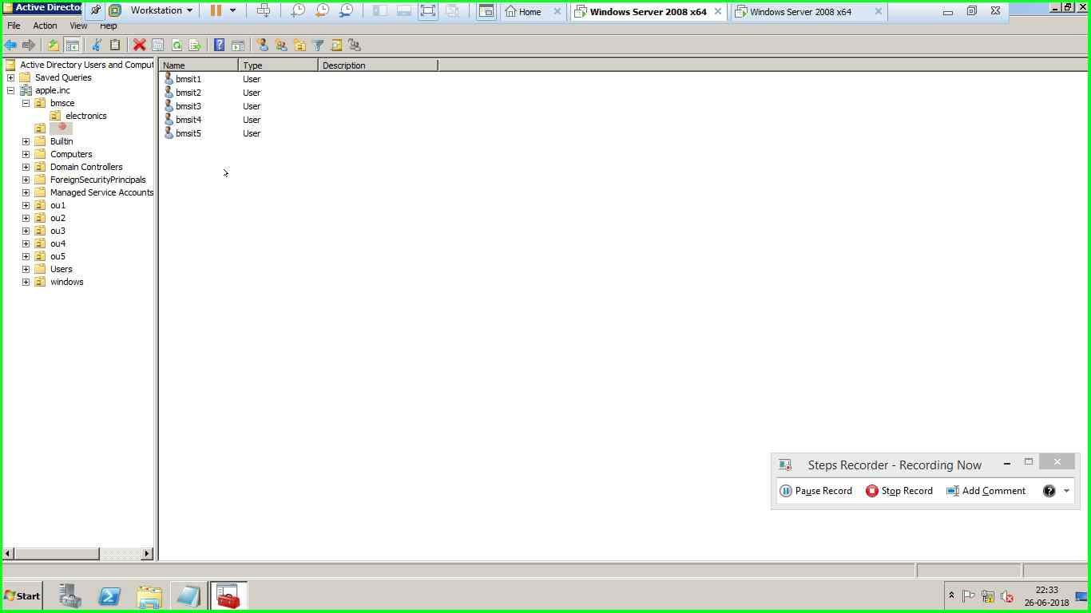

12)BMSCE OU has a child OU called electronics with 5 users in it

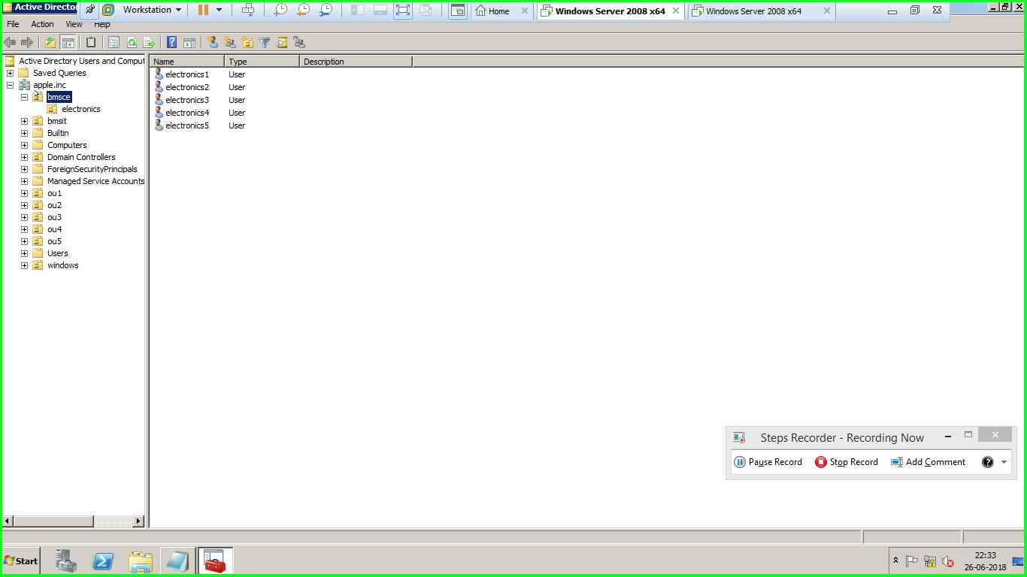

13)for the OU BMSCE a group policy is created with the following specifications

* Properties of computer is disabled

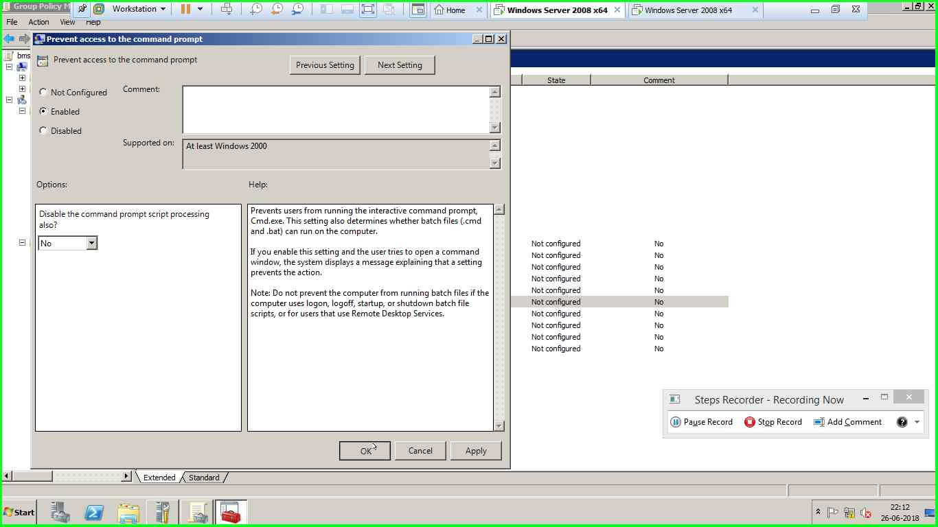

* Command prompt is disabled



* Recycle bin is hidden

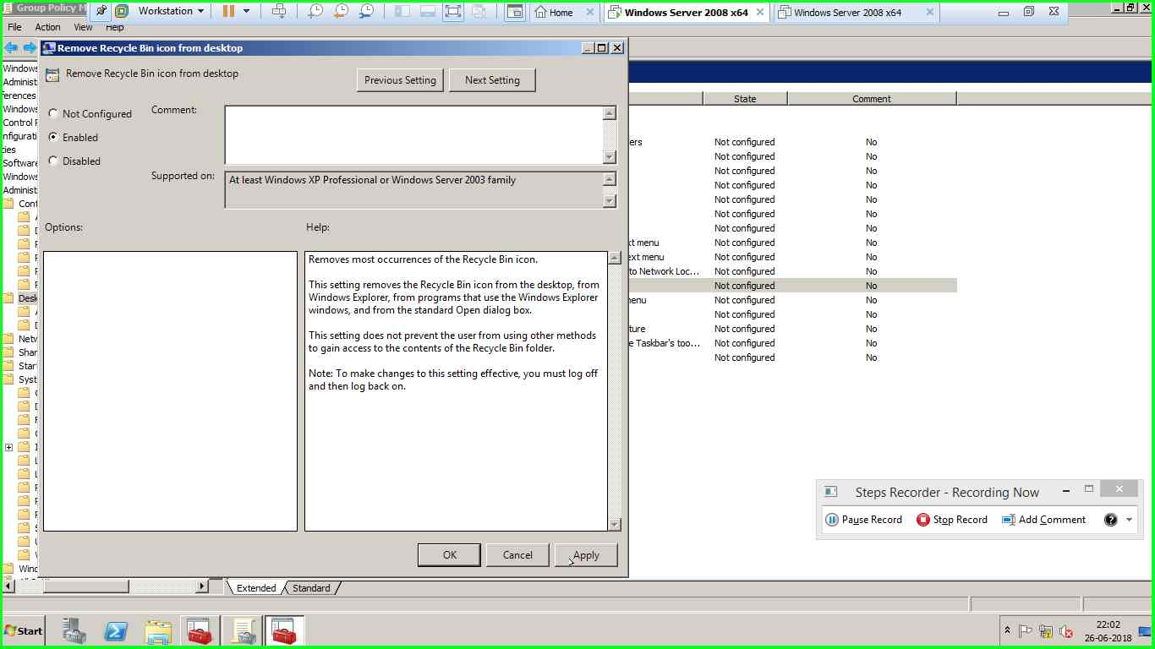

* Shutdown is removed

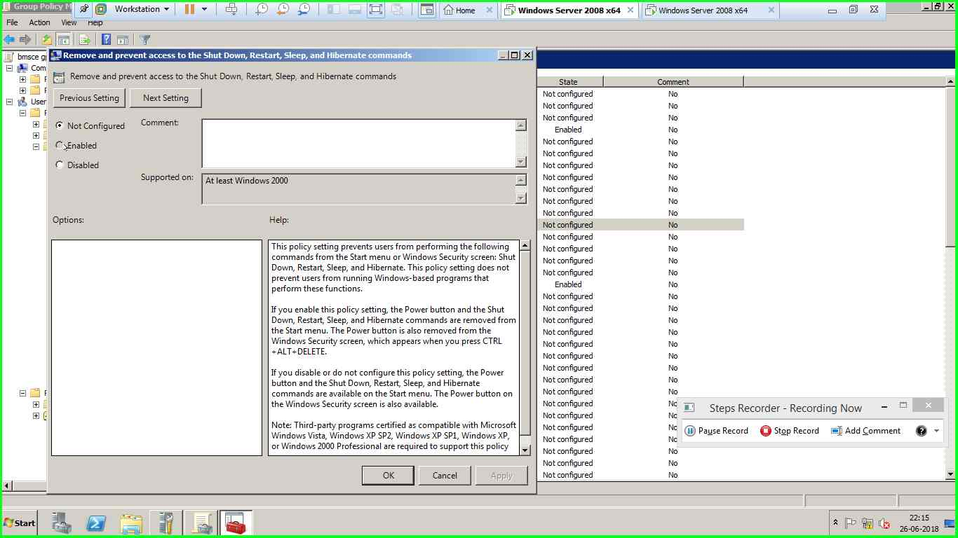

* Logoff is added

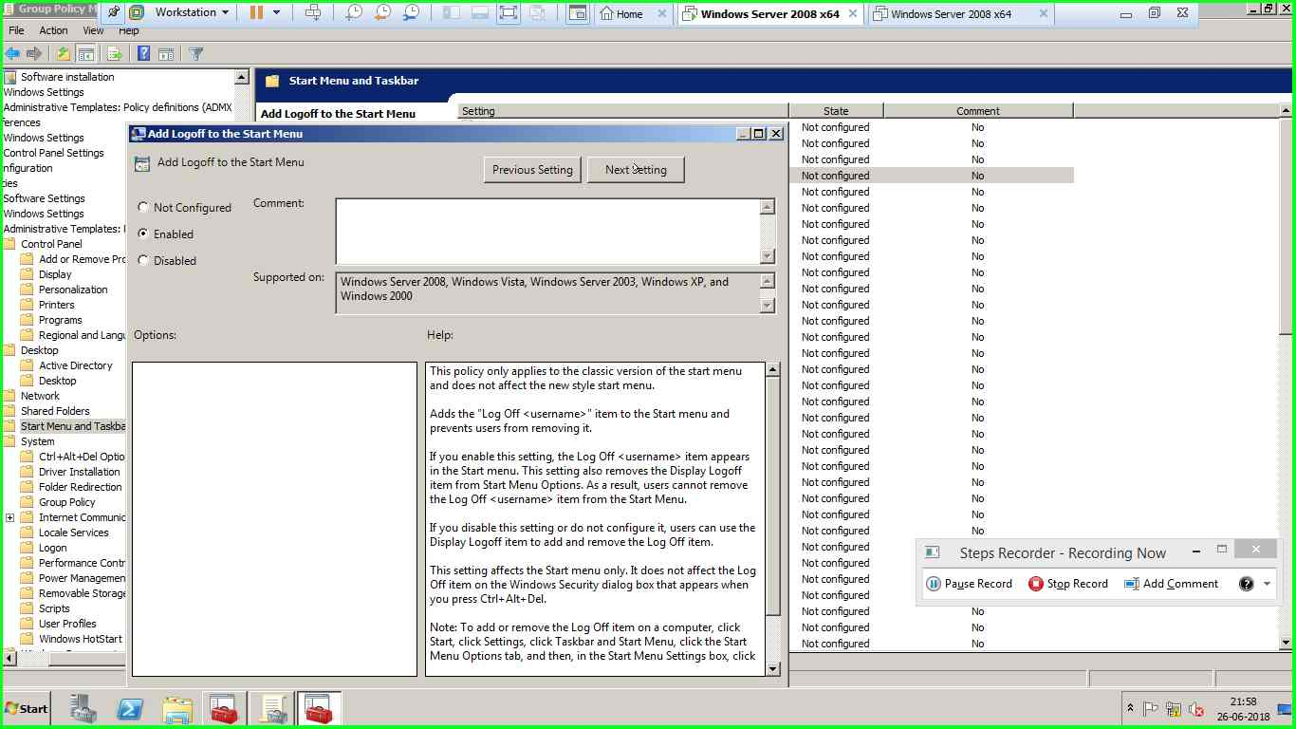

* Games are removed

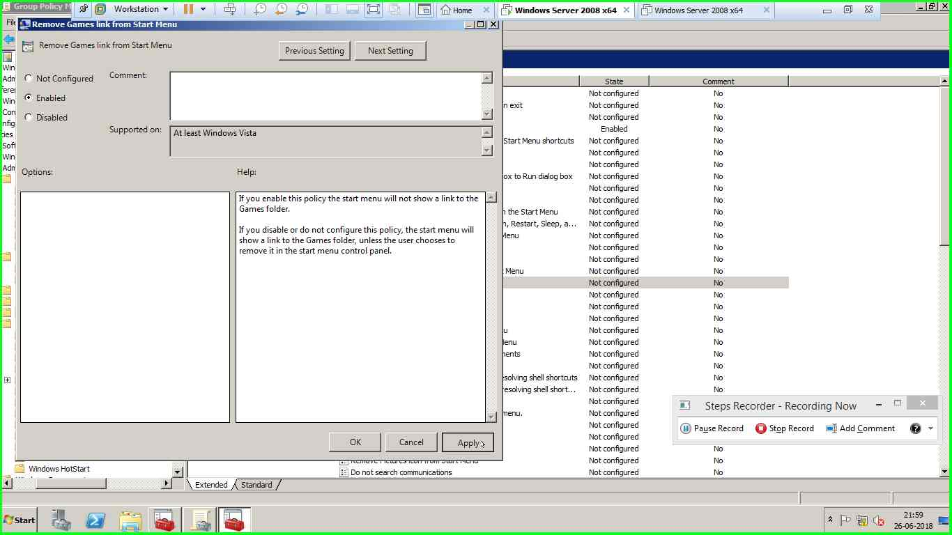

14) 5 users can logon between 11AM and 7PM -here the logon timing has been done for user 1 , similar steps are followed for user2; user3; user4; user5

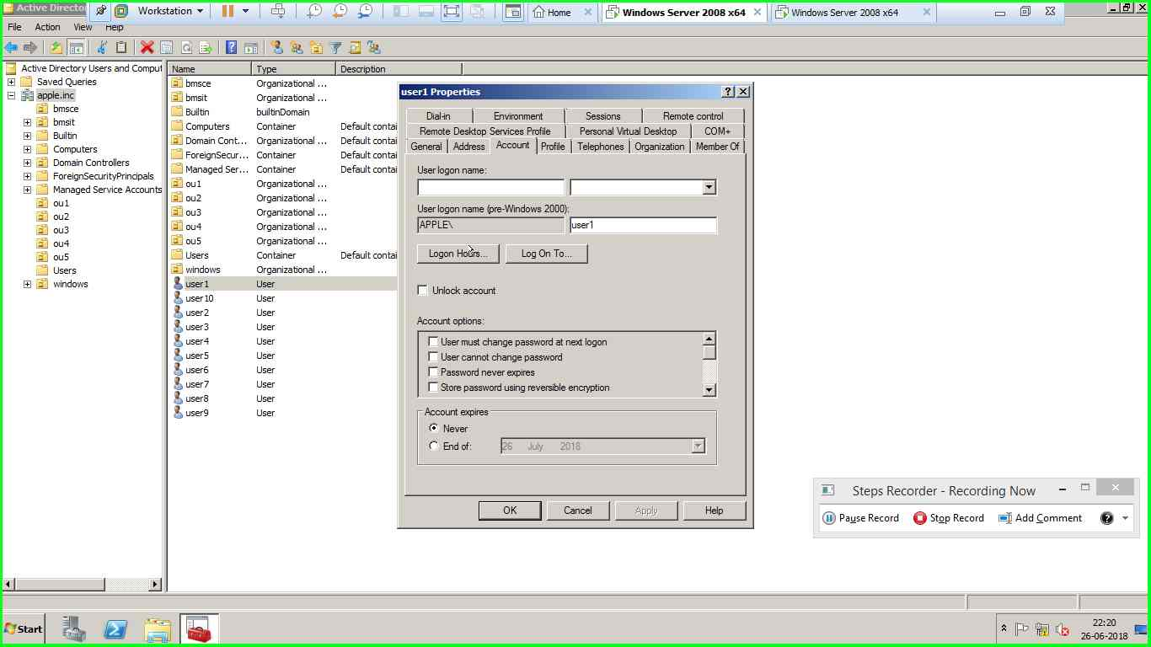

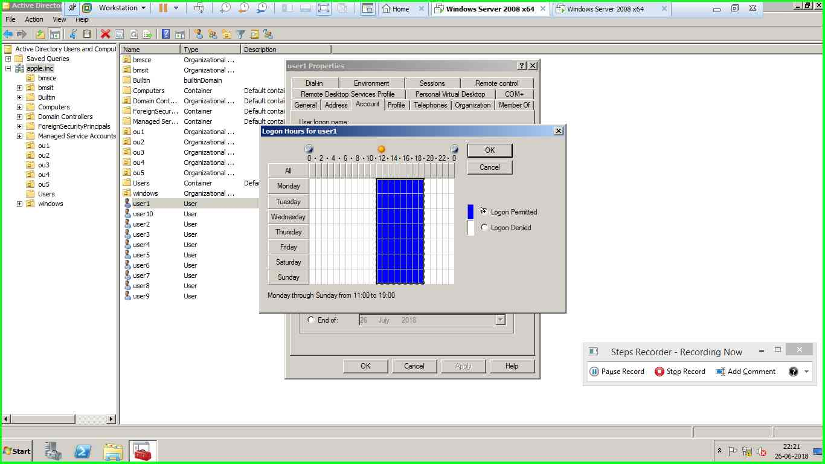

15) users have log on access fom PC01 –here the logon for user 3 has been permitted from only PC01 , similar steps are followed for other 5 users.

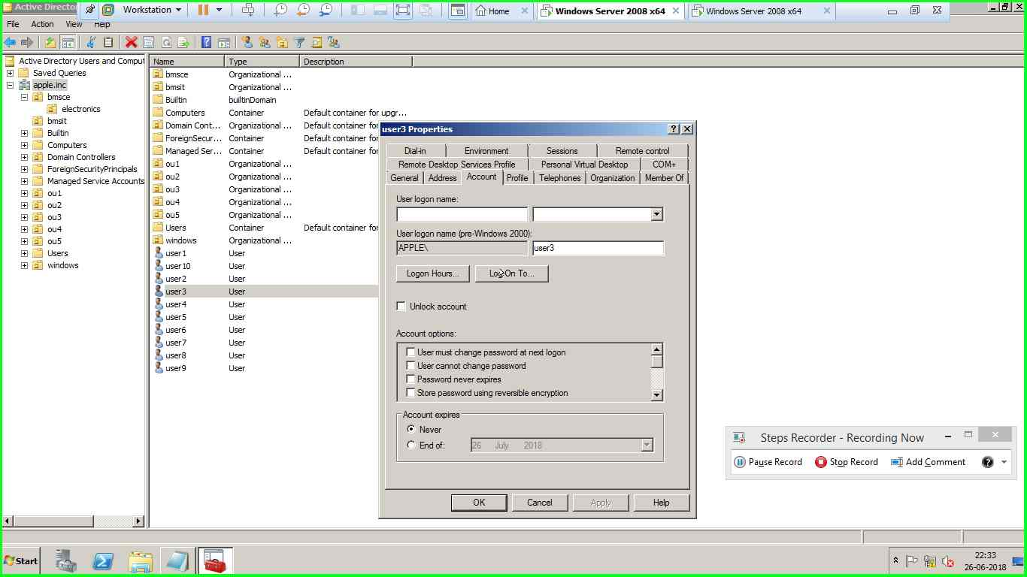

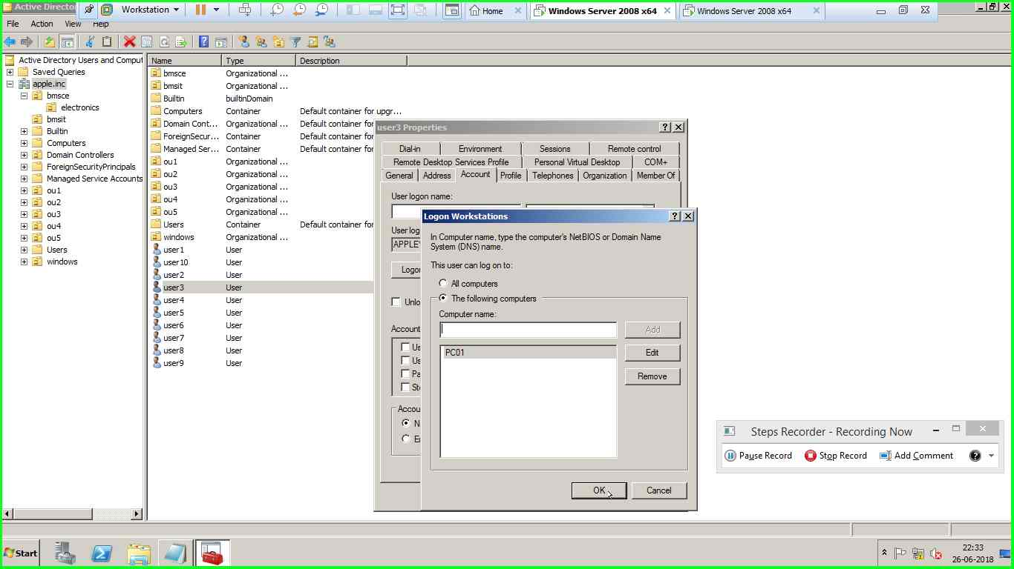

**Part2**

Create a shared folder on win 10 and share with full control permission and enable sync centre

1) create a E drive of 2 GB FAT

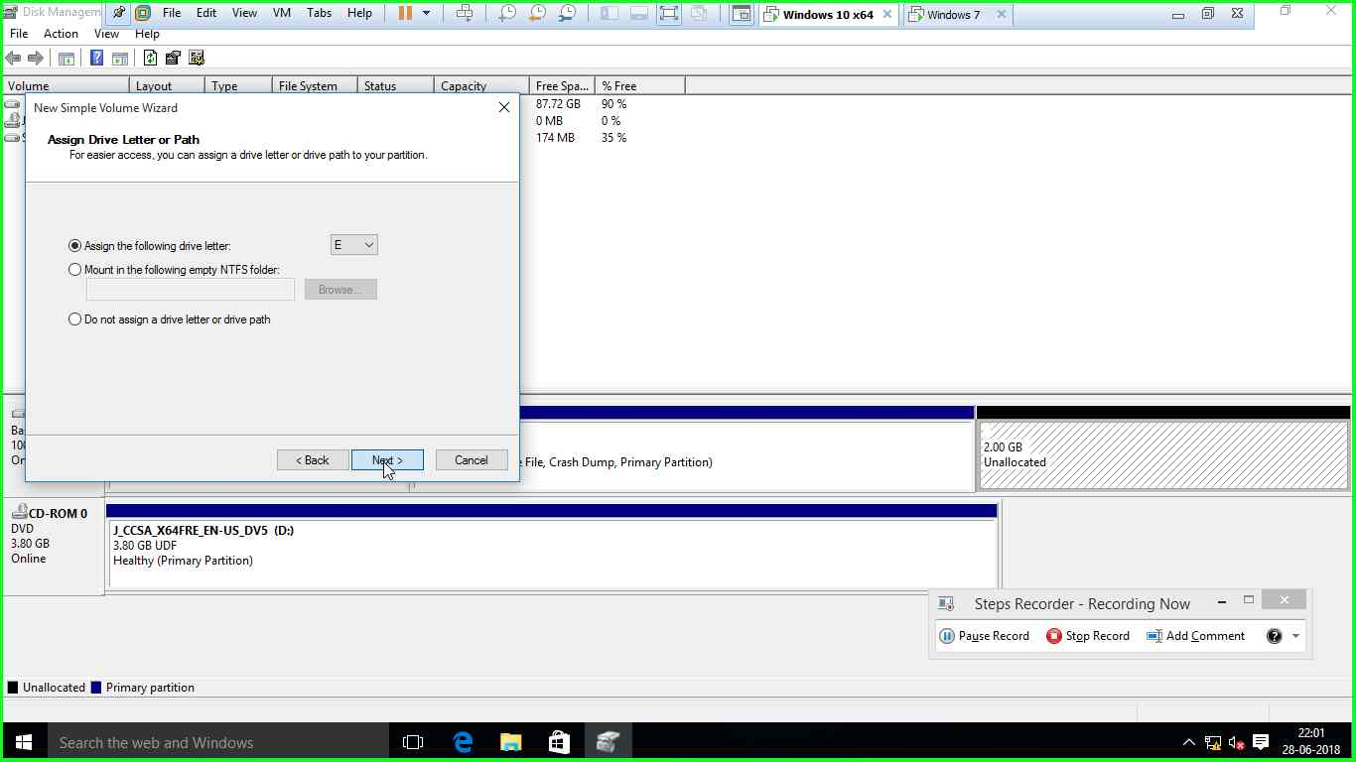

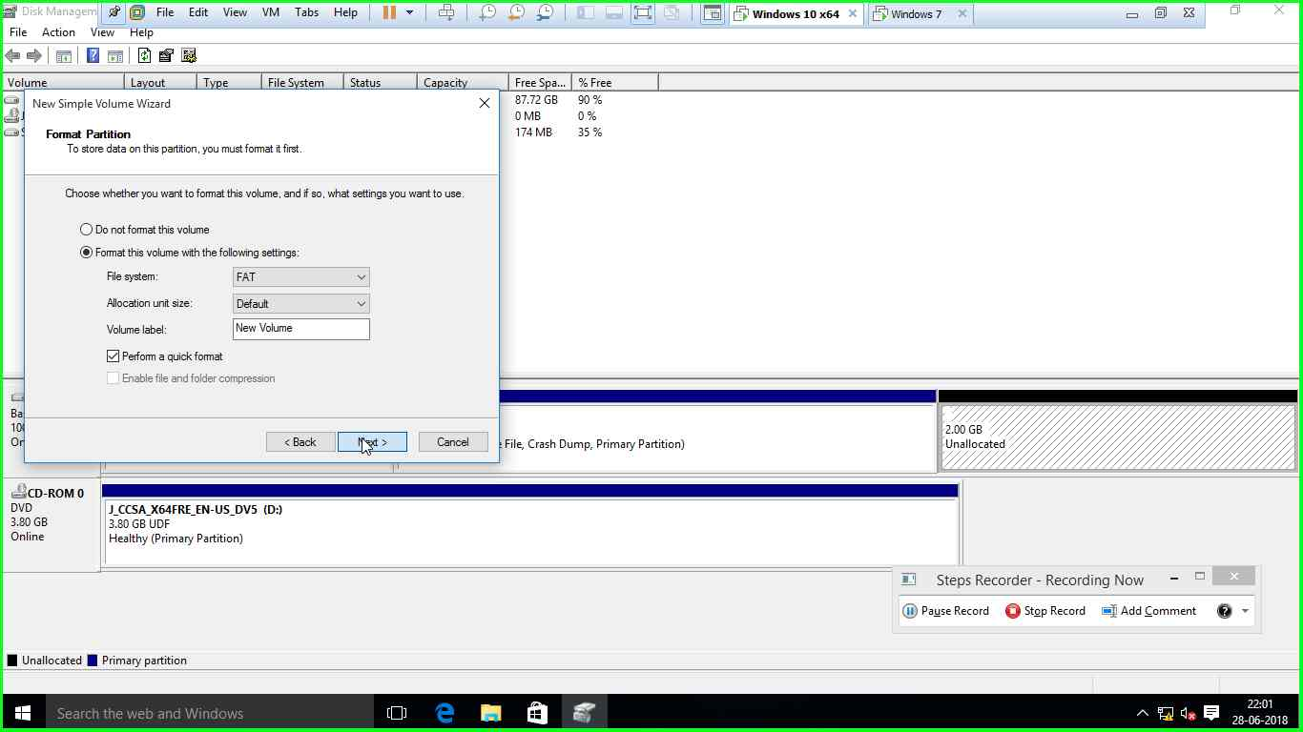

2)create a F drive of 5 GB FAT32

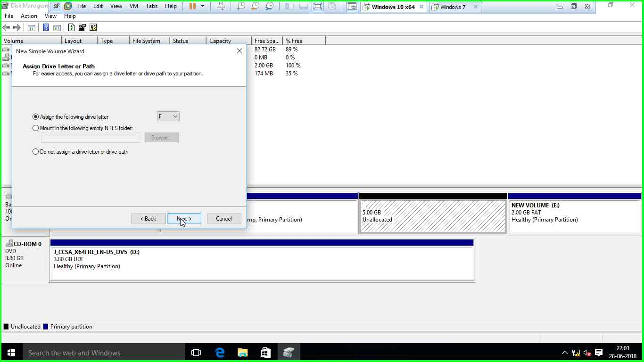

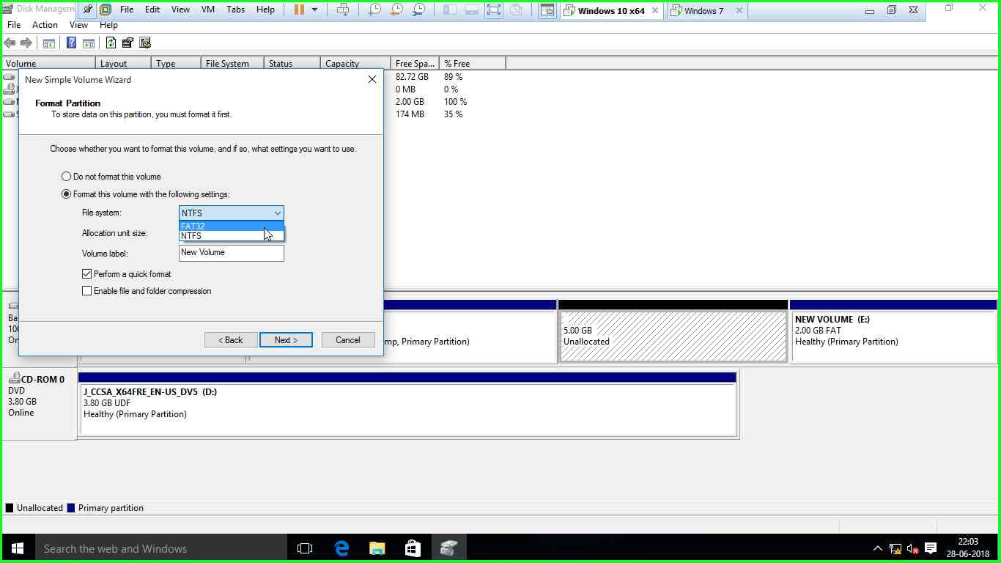

3)create a G drive of 10 GB NTFS

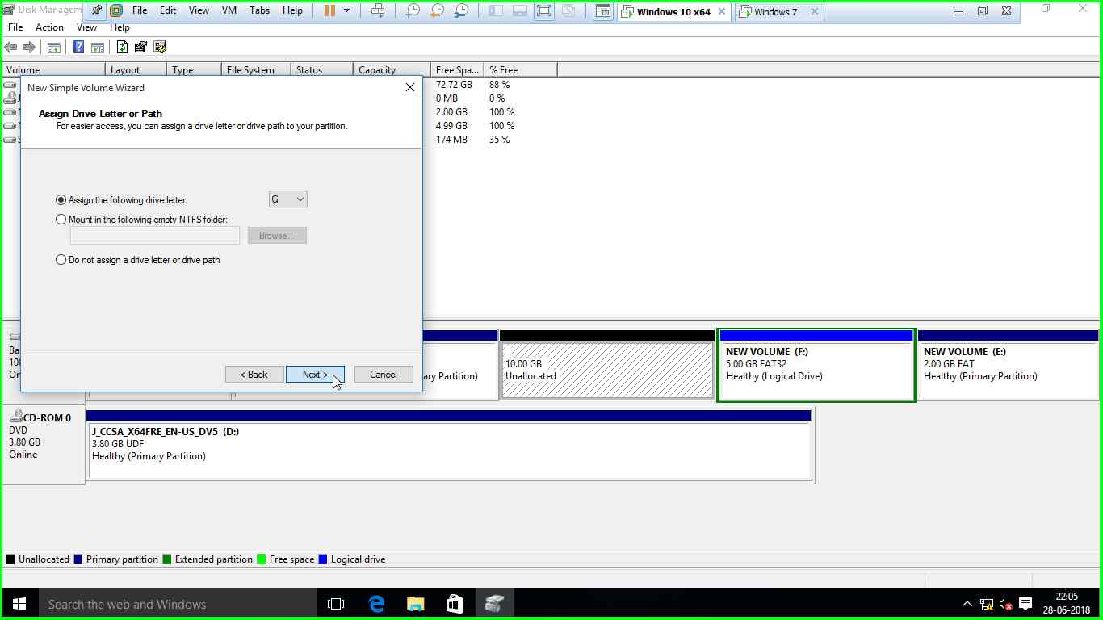

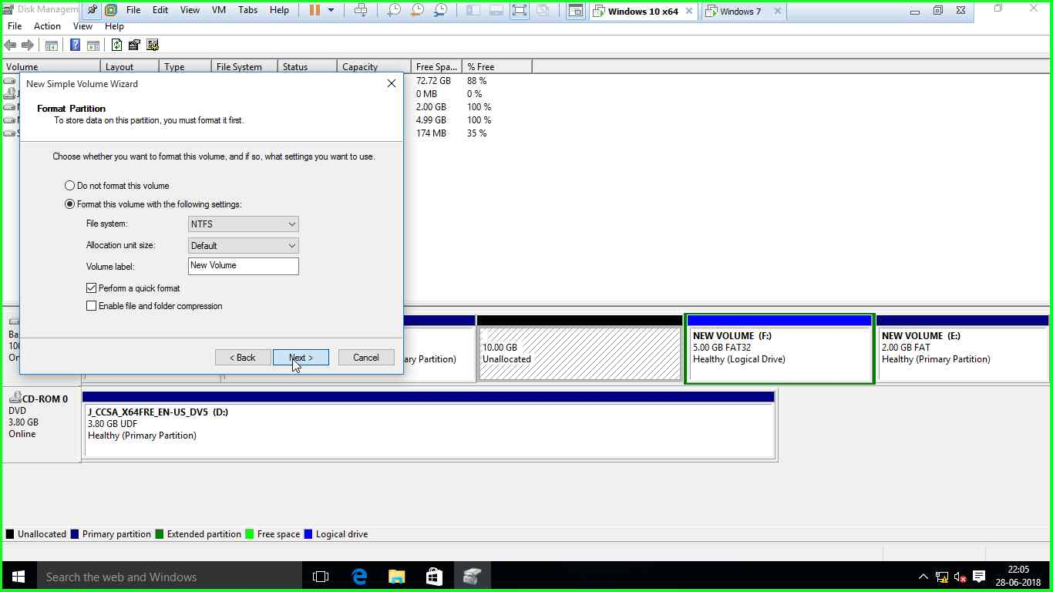

4) create a remote desktop session between win7 and win 10

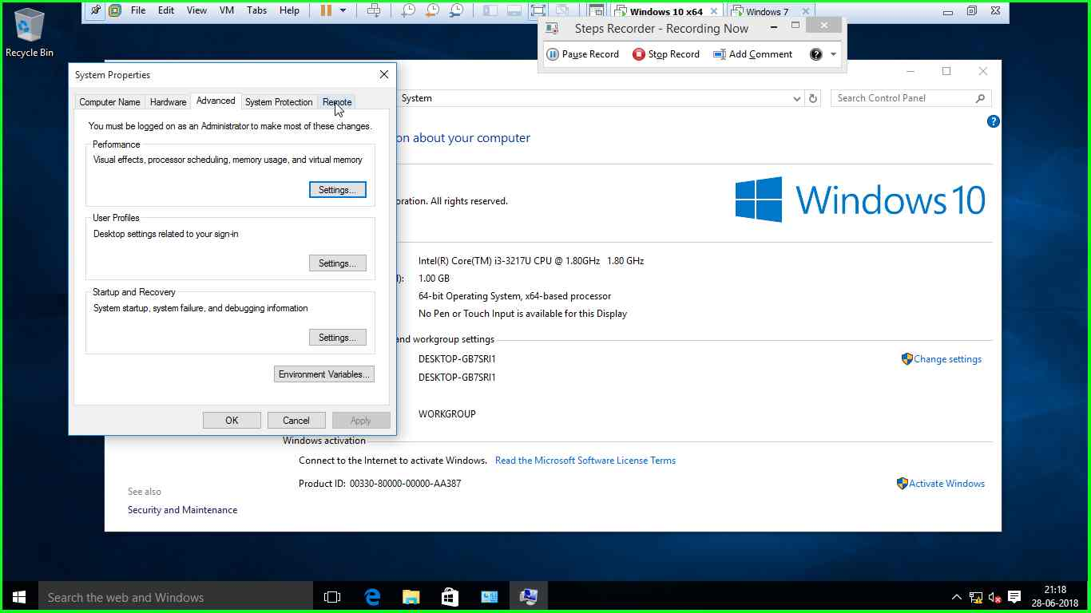

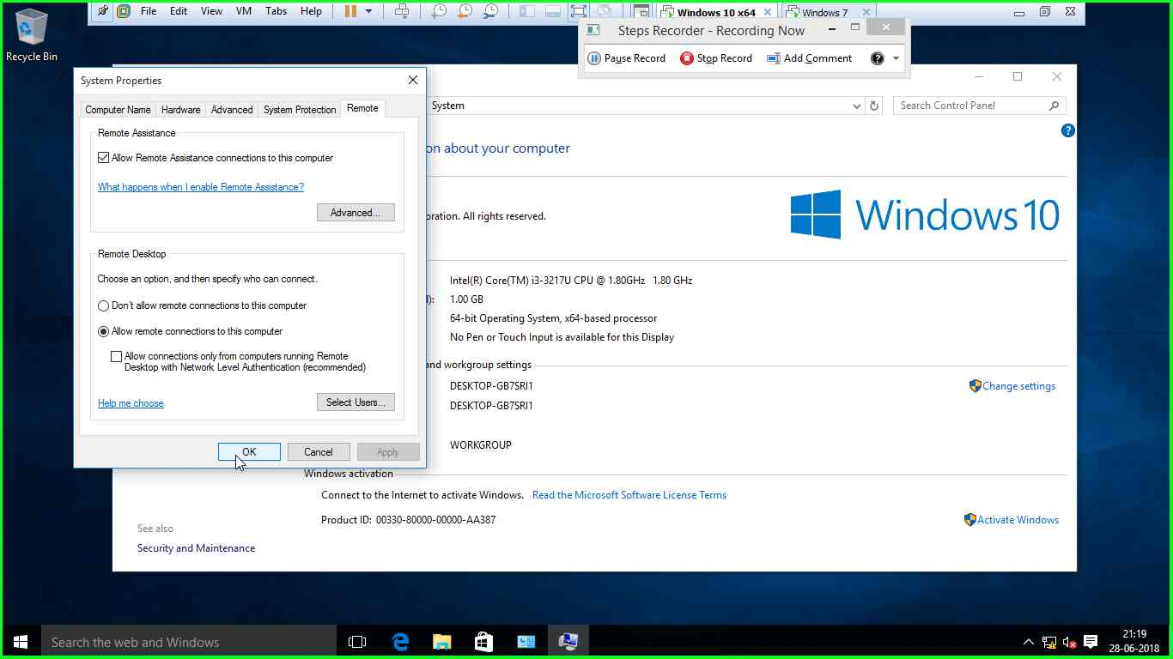

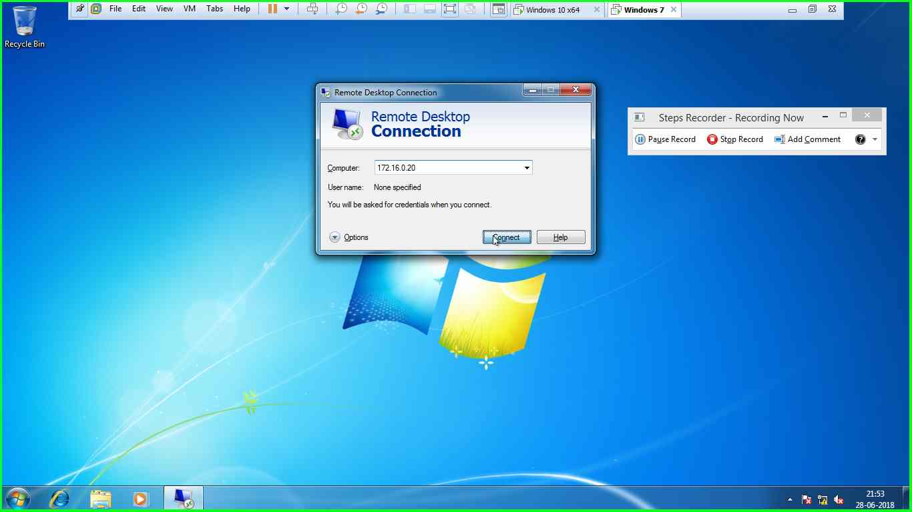

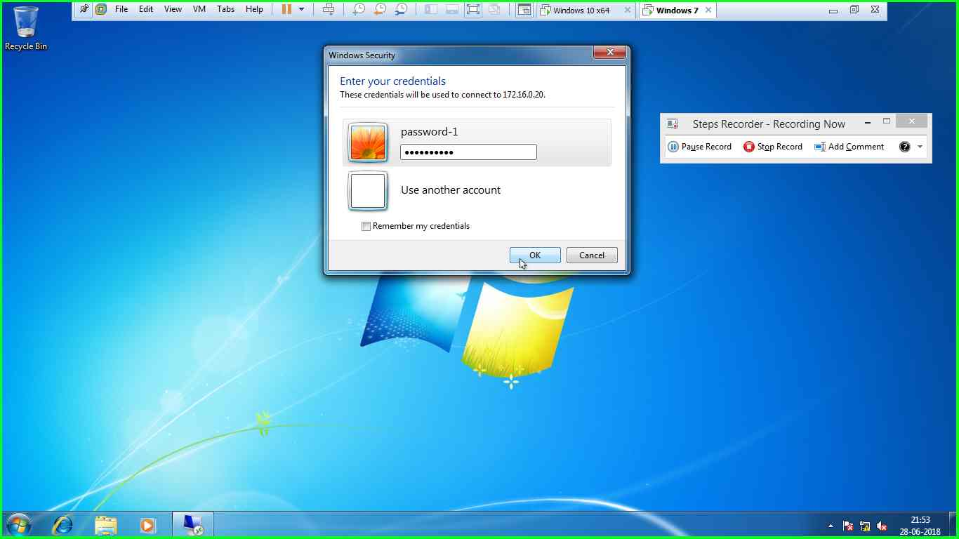

5) create 3 users and make ws01 as the administrator however the other users are network configuration operators group

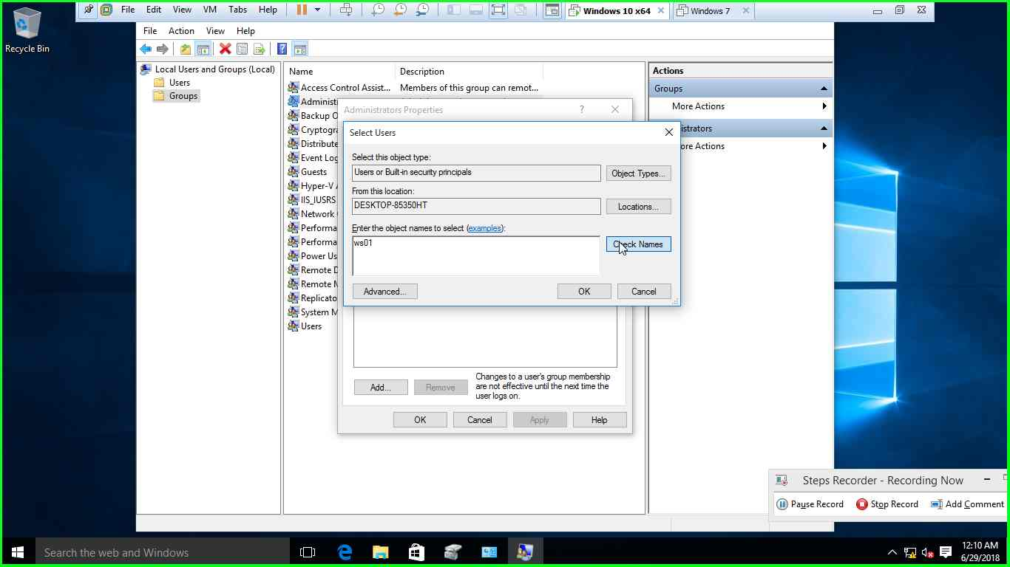

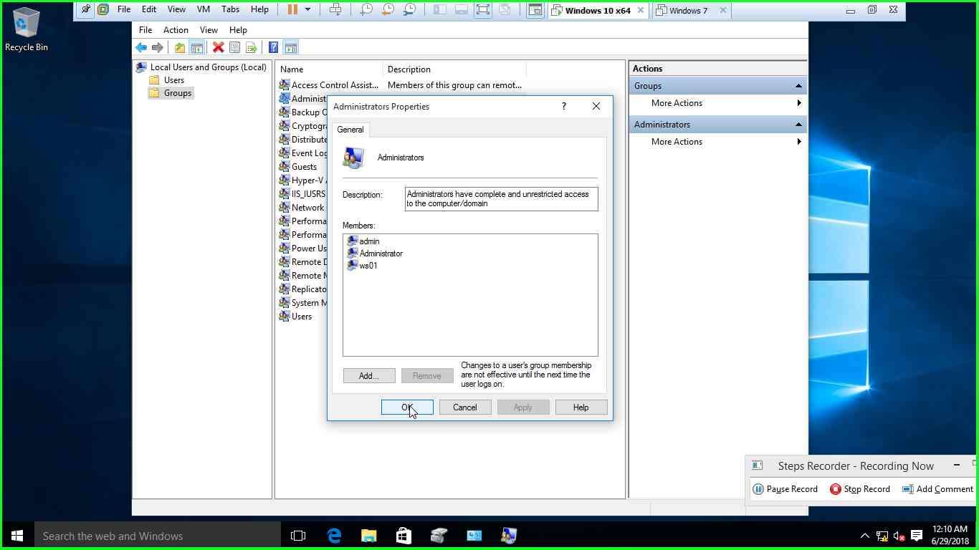

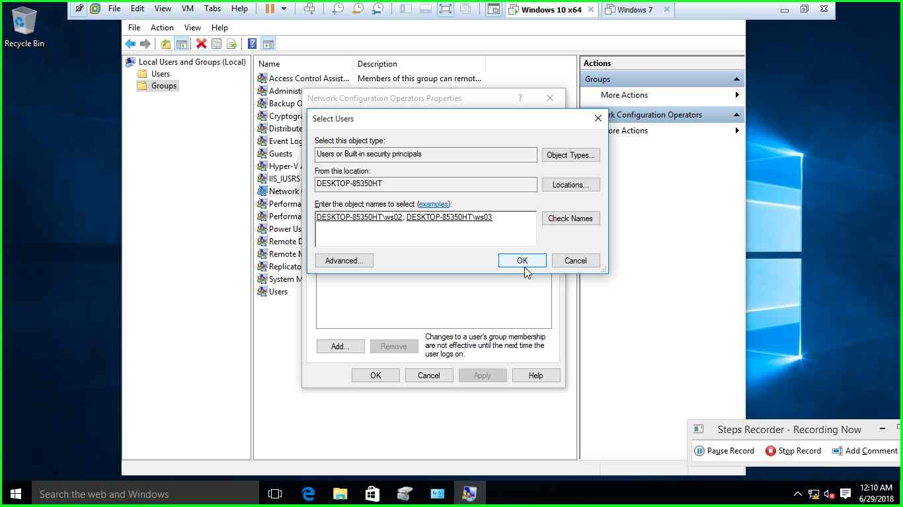

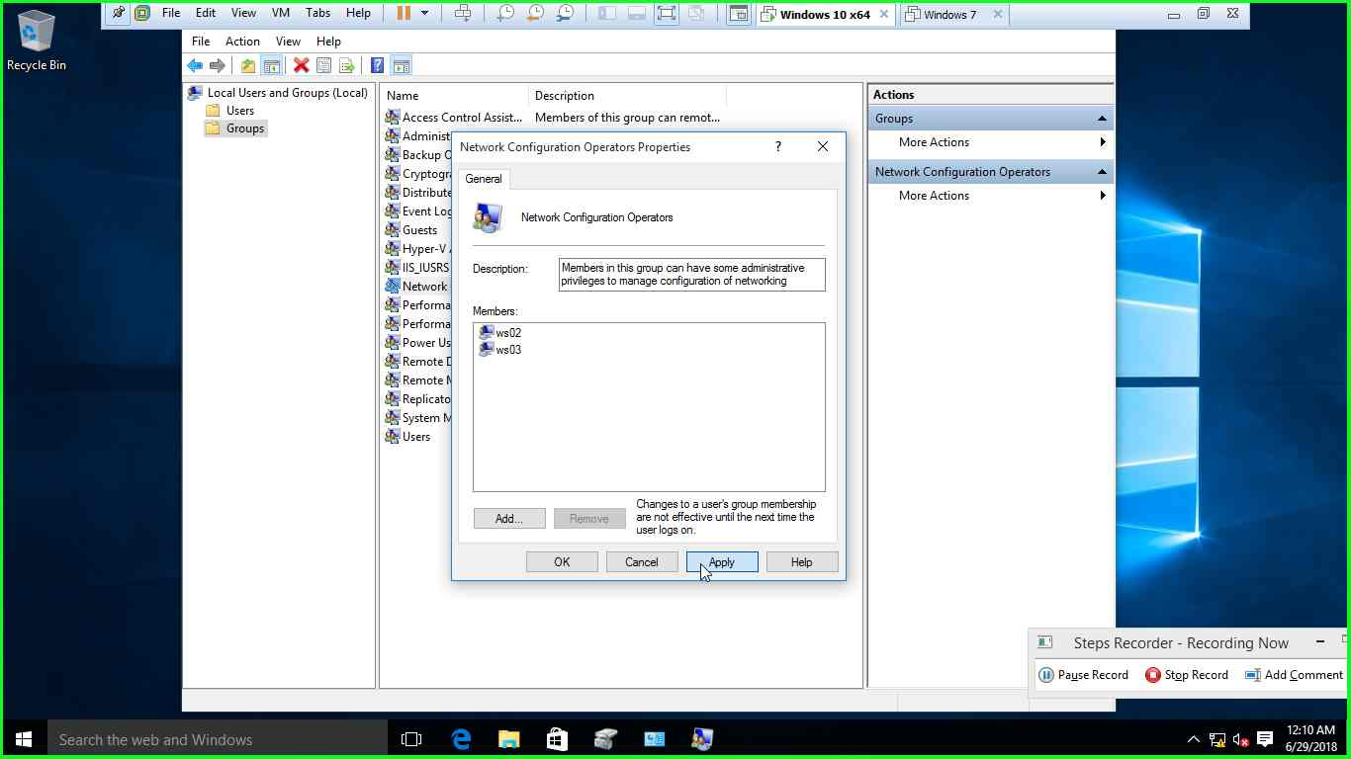

6)convert the FAT/FAT32 into NTFS

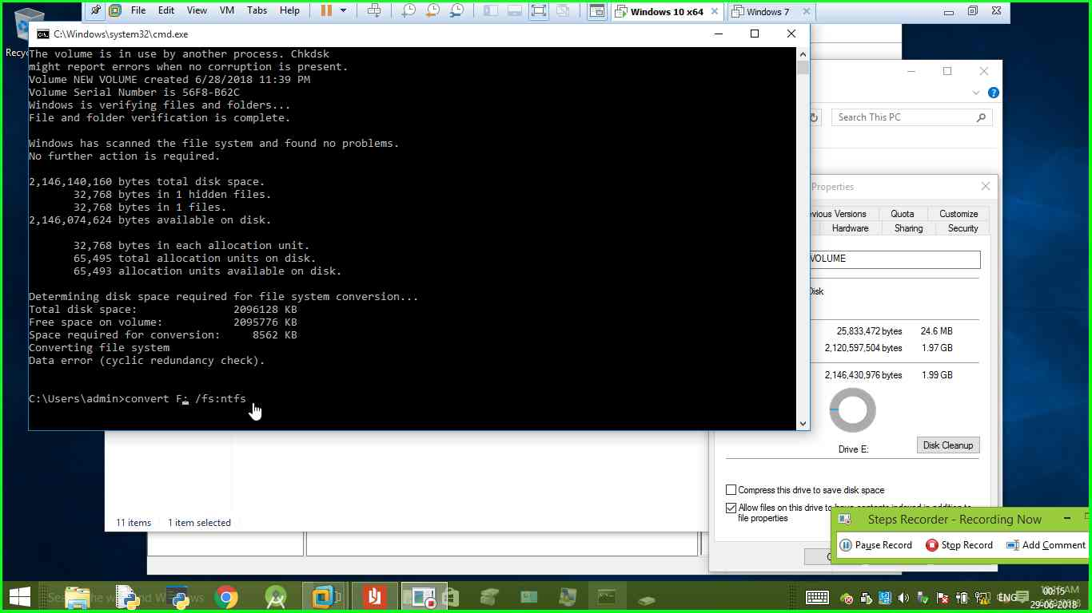

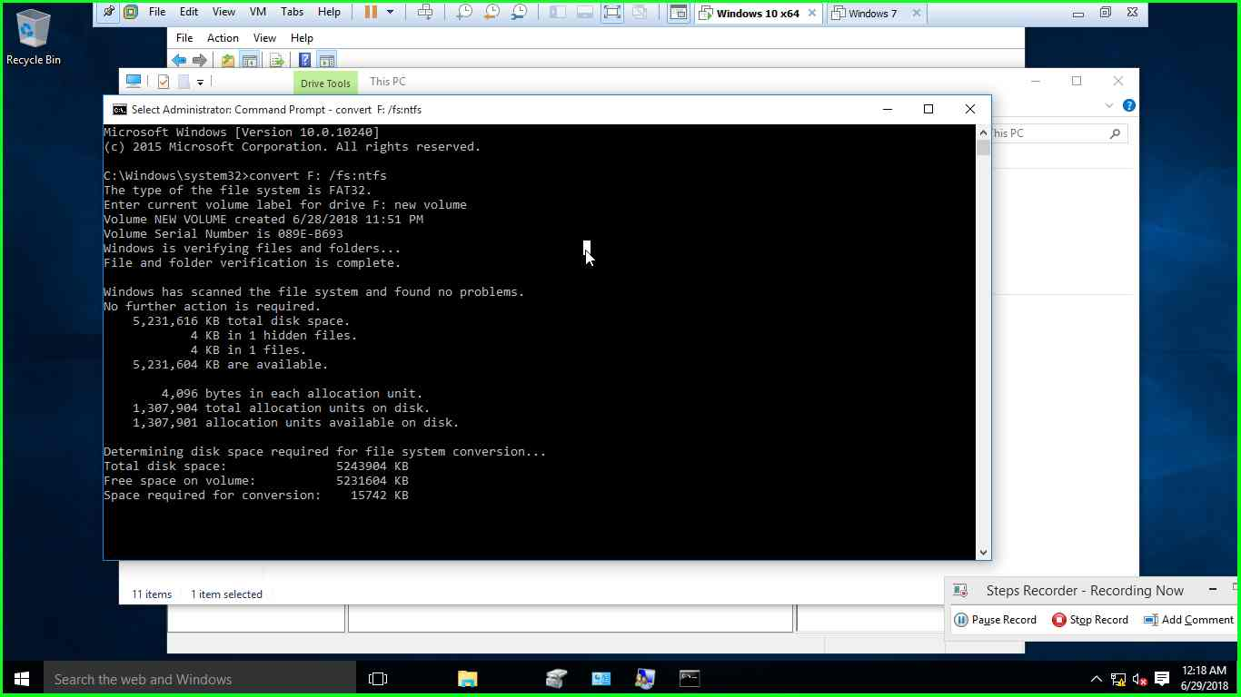

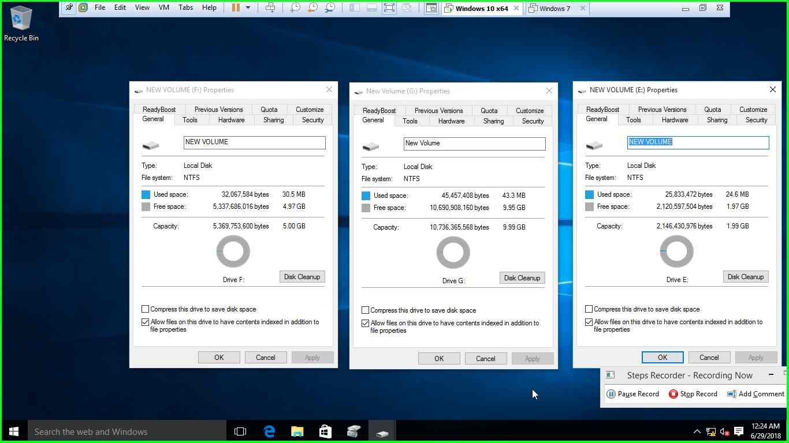

7)create users and groups based on the below specifications

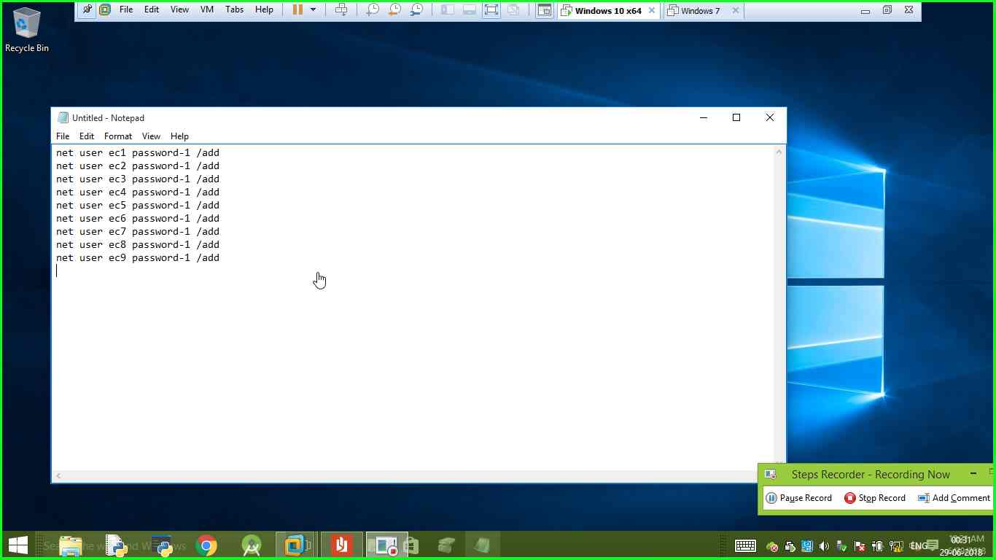

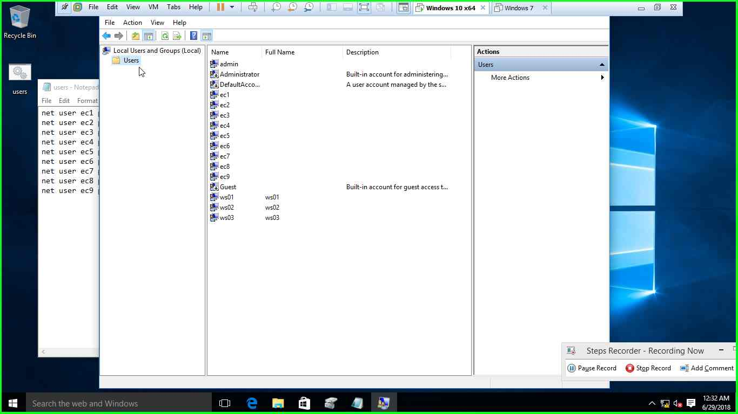

Group1- EC1 , EC2 , EC4 , EC6

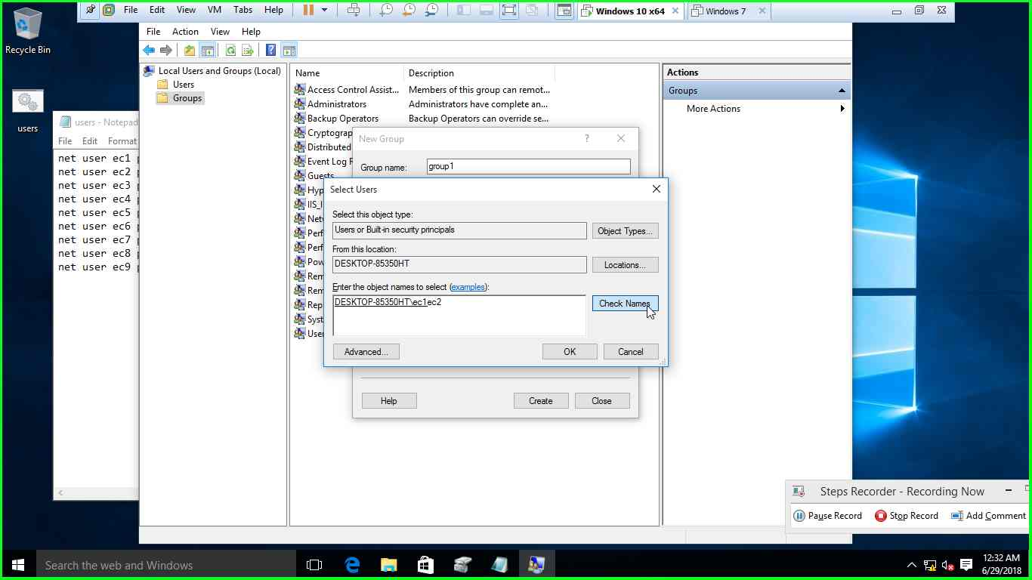

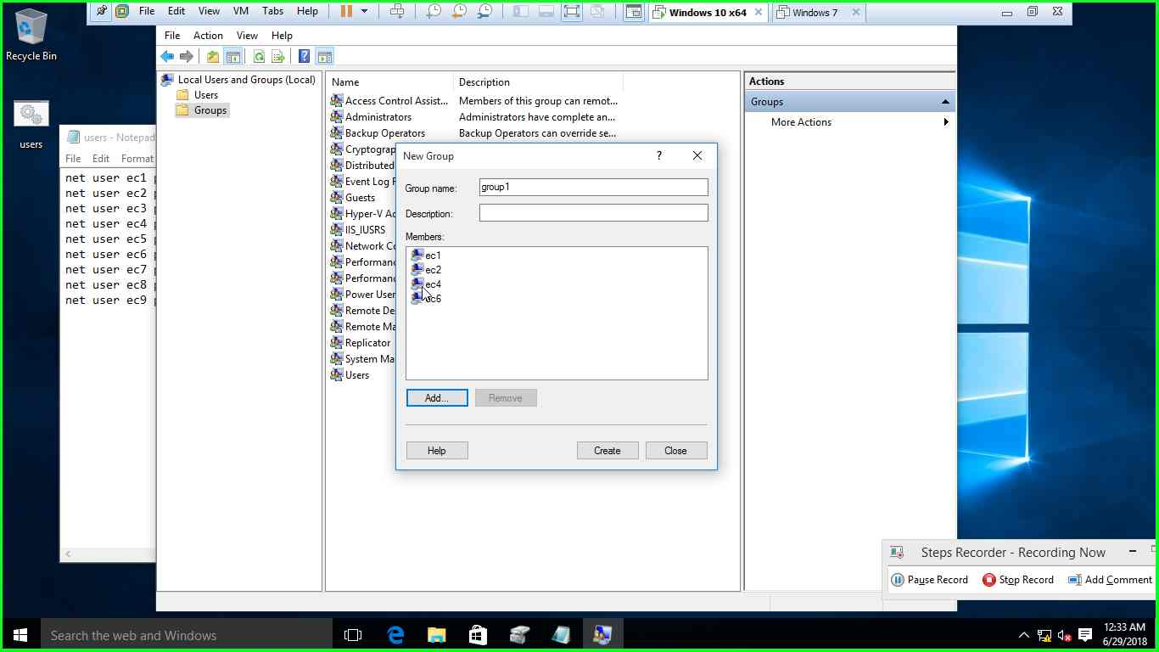

Group2- EC3 , EC2 , EC4 , EC8 , EC9

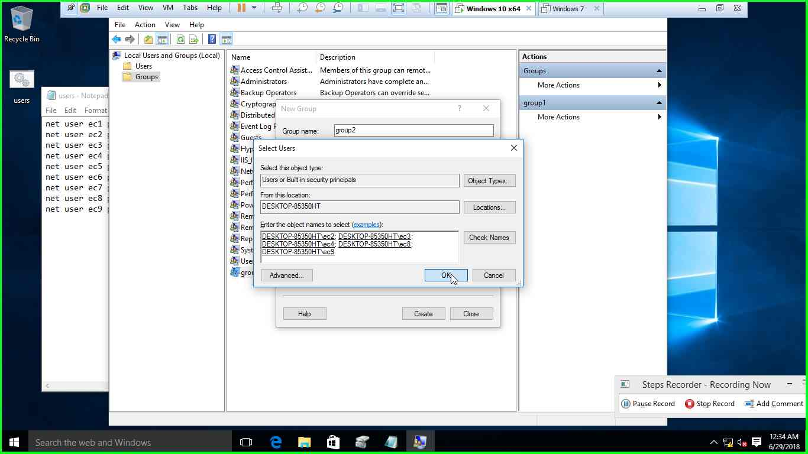

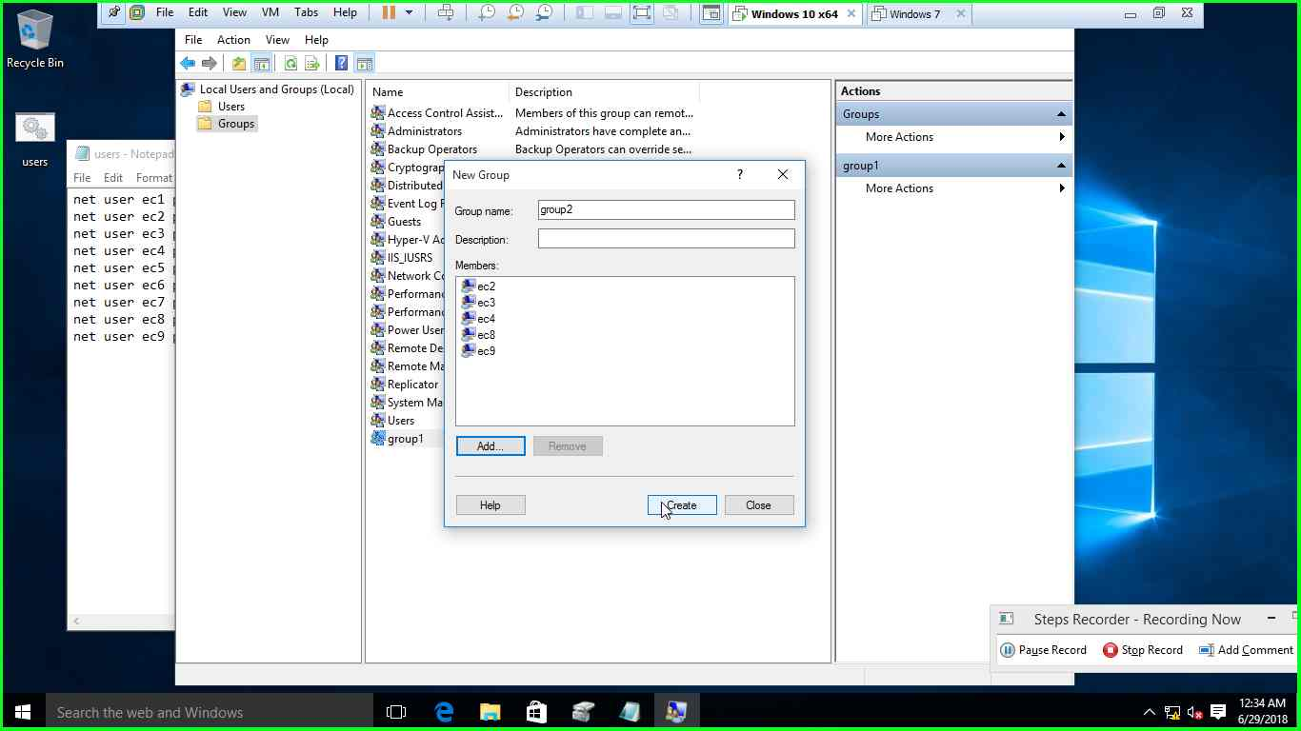

Group3- EC1 , EC7 , EC5 , EC6

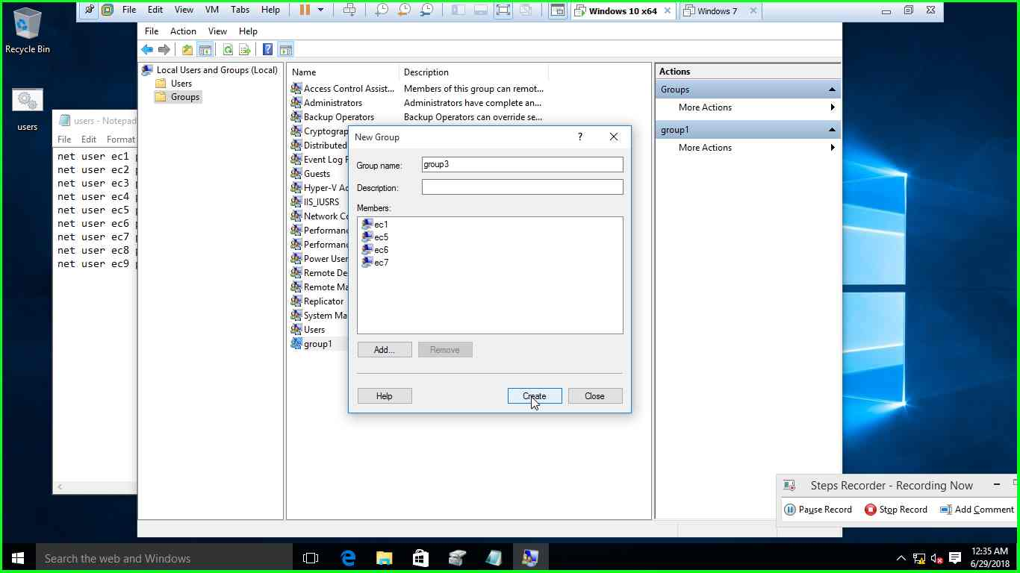

Group4- EC3 , EC5 , EC7 , EC8

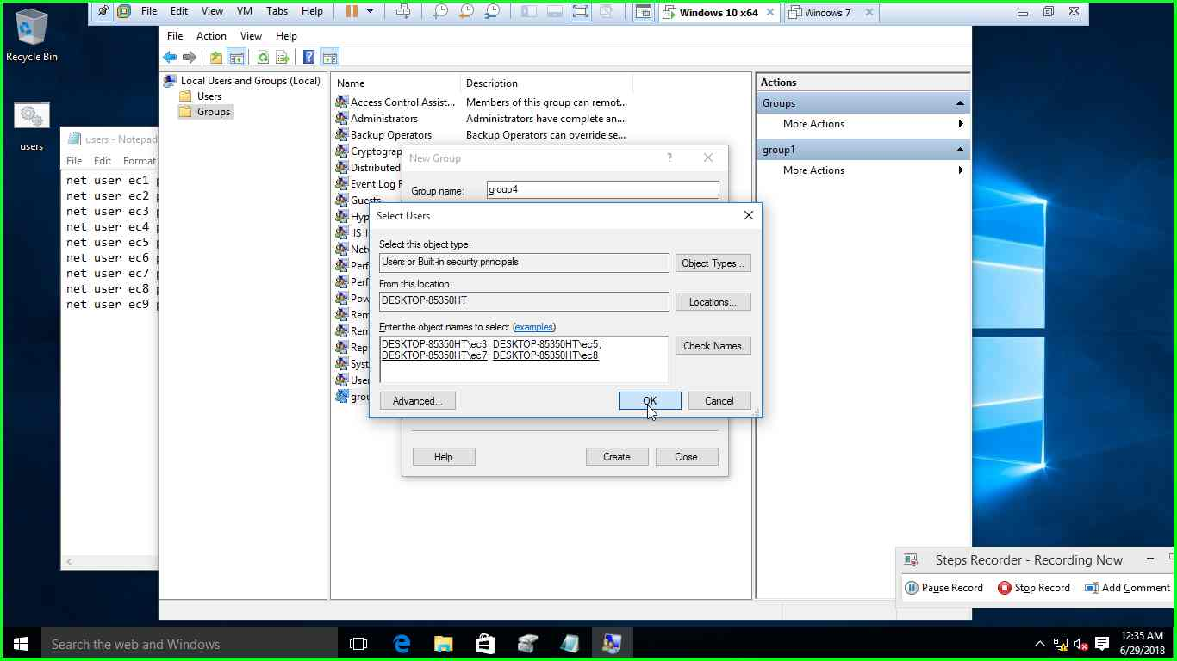

8)for a particular drive the access permissions are given as follows

Group1 – read only

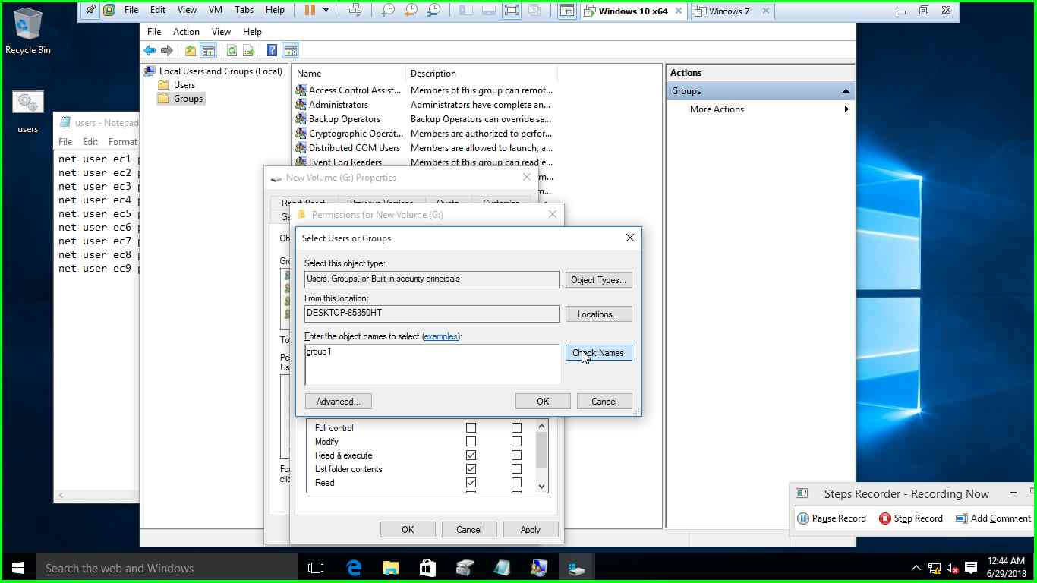

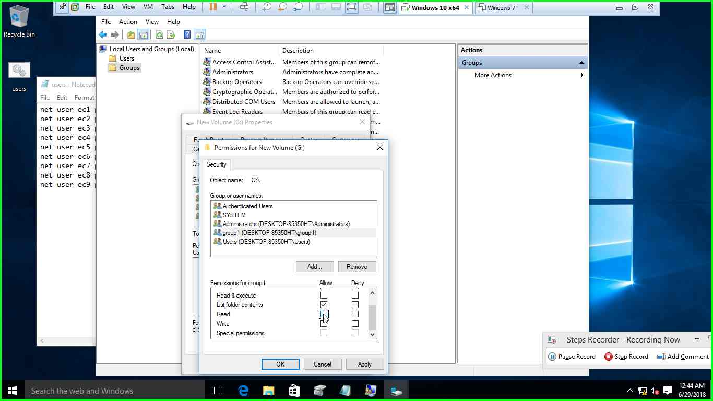

Group2 –read / write

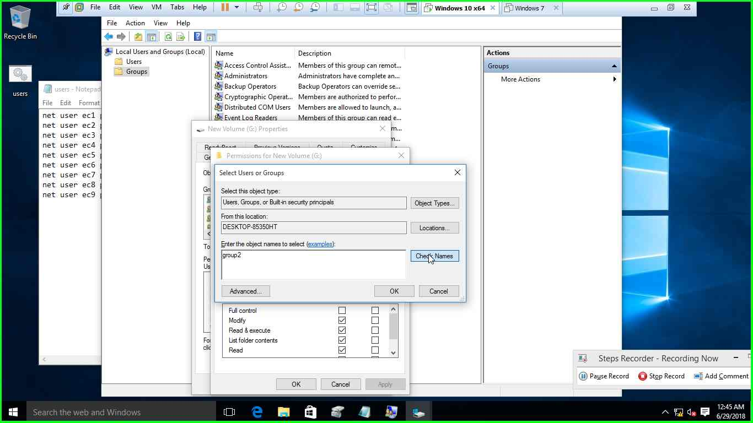

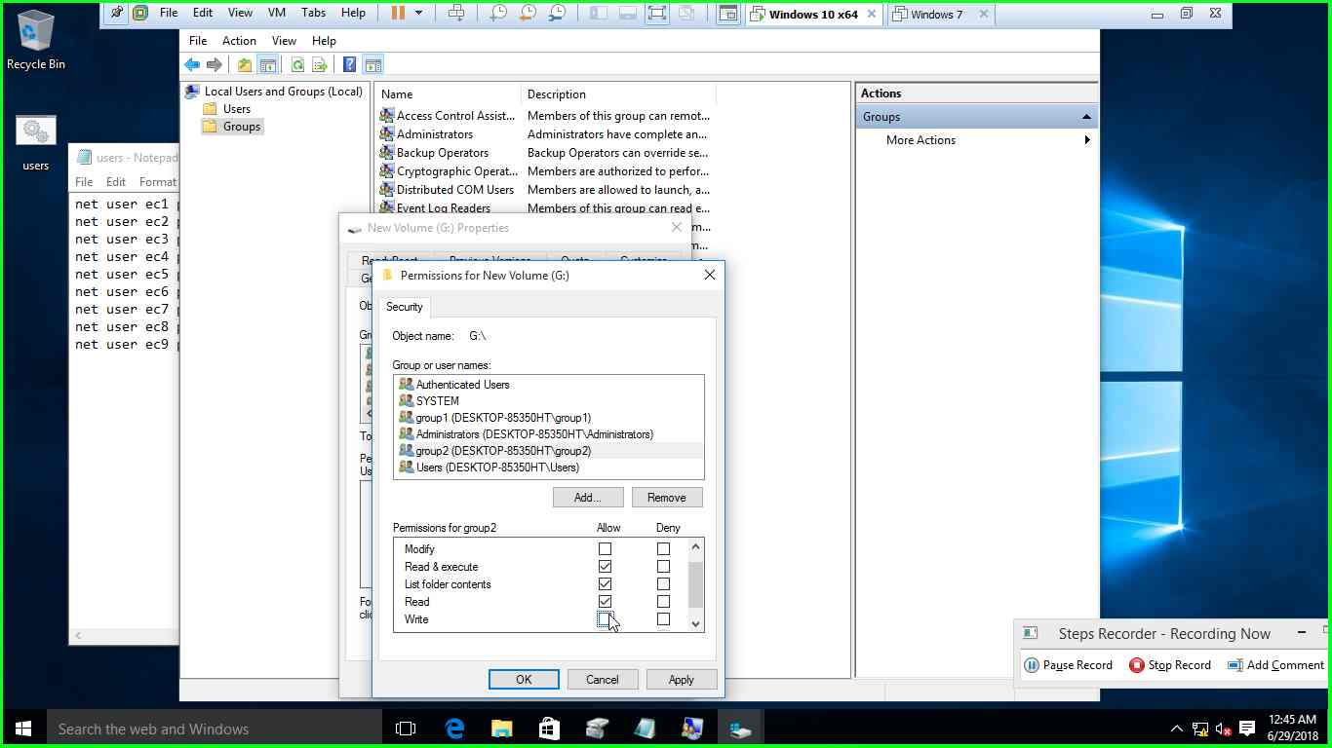

Group3 –full control

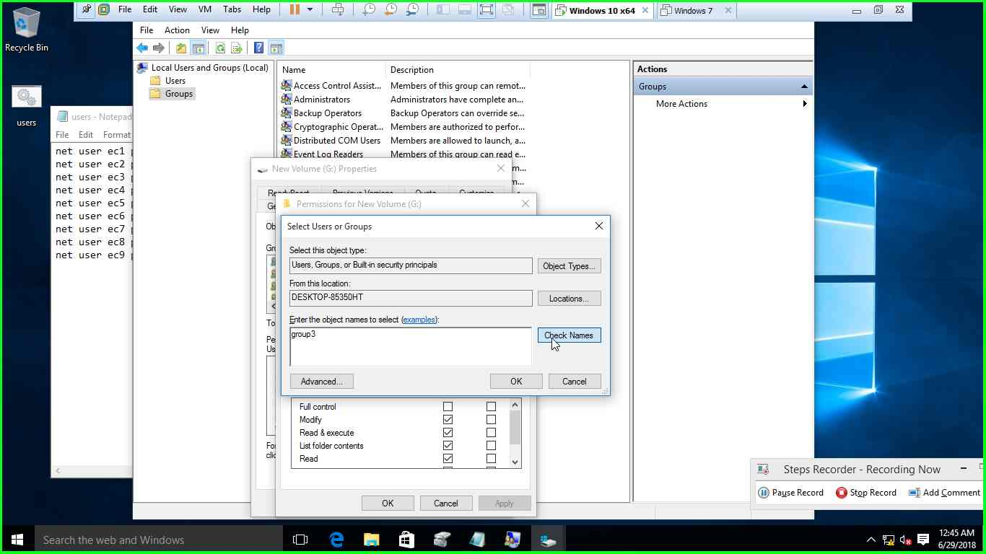

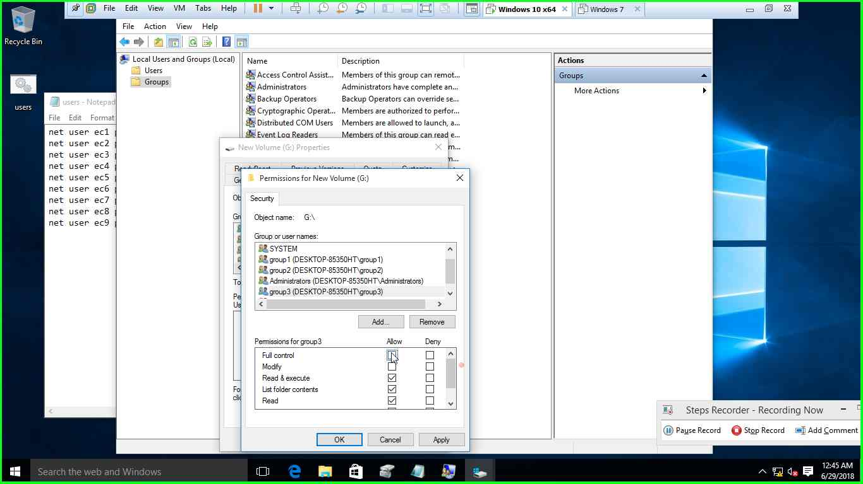

Group4 –access deny

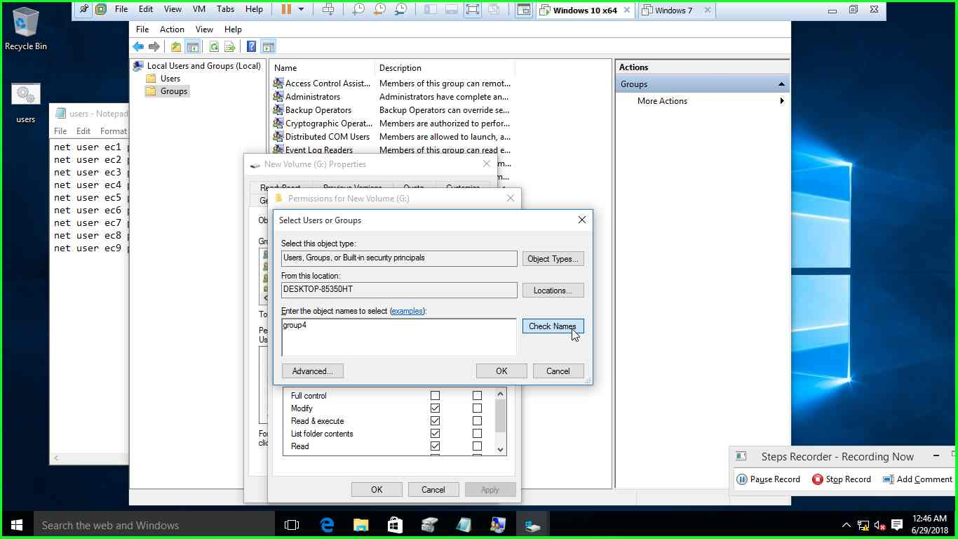

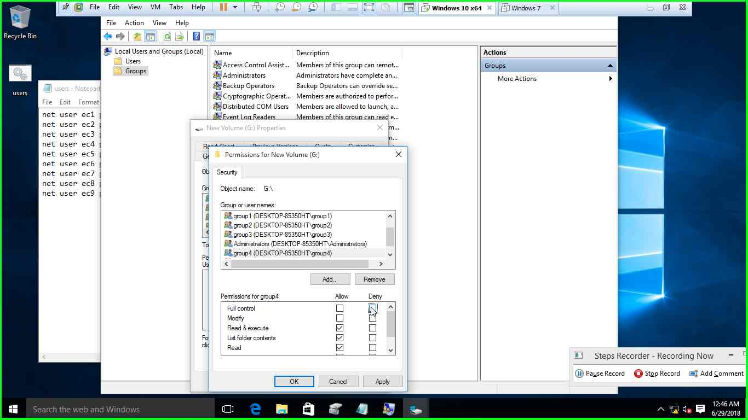

9)enable interactive logon title and interactive logon text

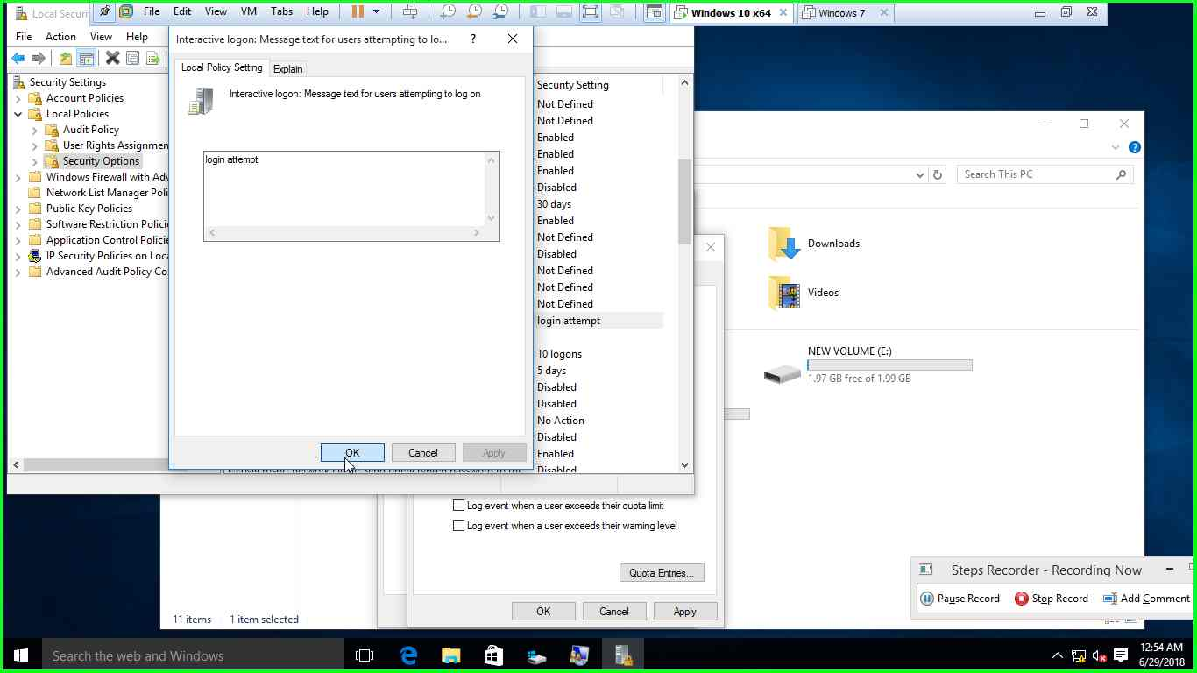

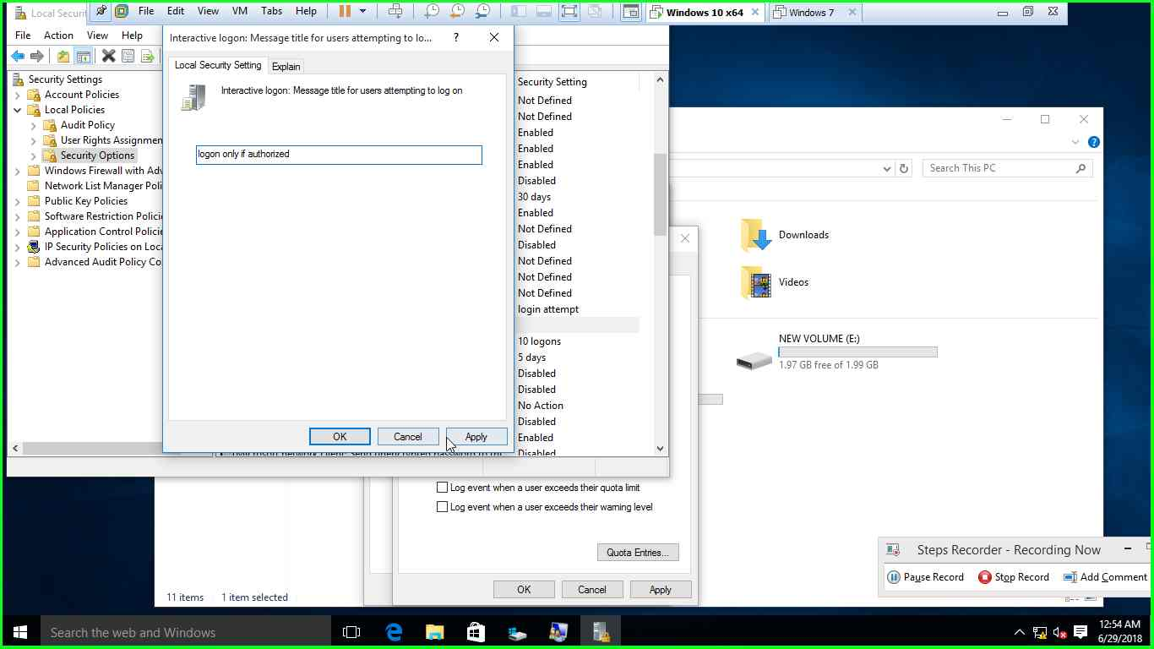

Enable logon audits only on successful logon

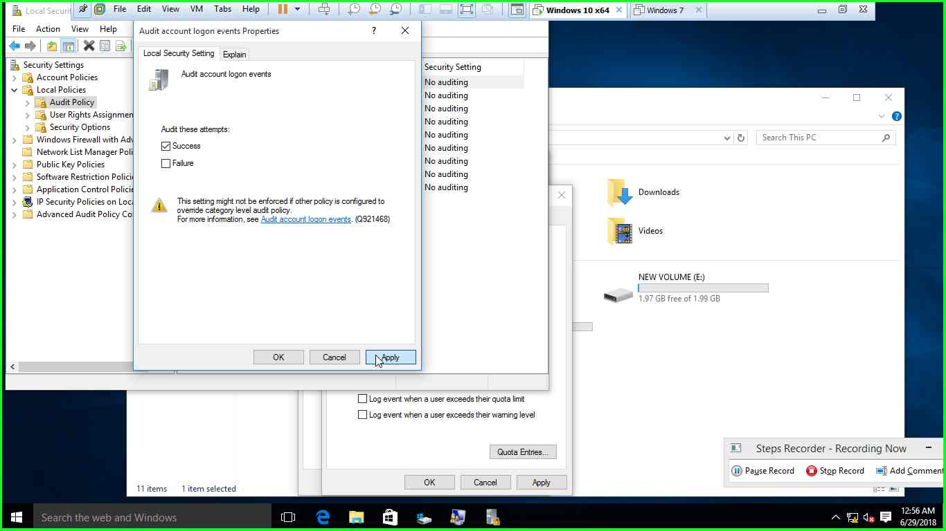

10) enable disk quota for EC1 as 5GB in C drive

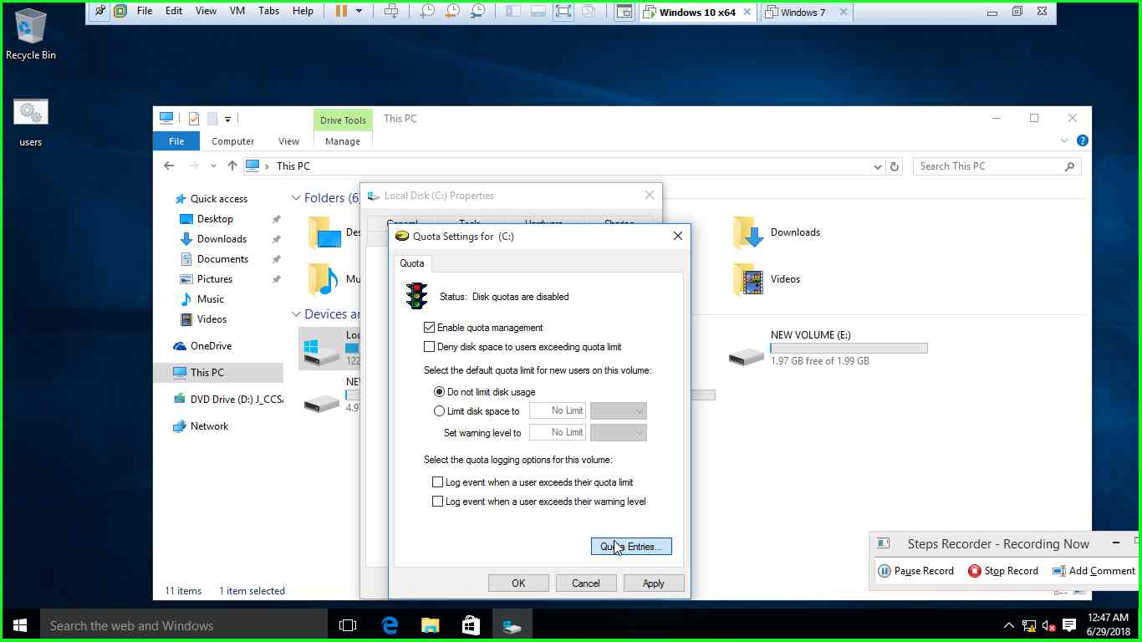

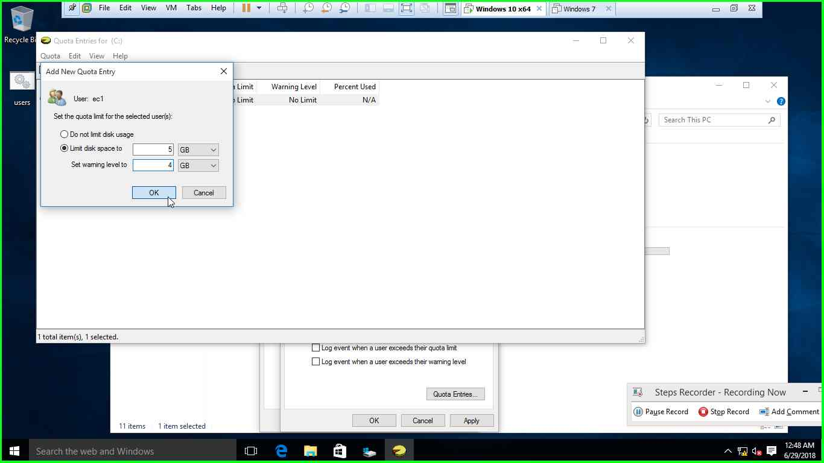

Enable disk quota for EC2 as 1GB in C drive

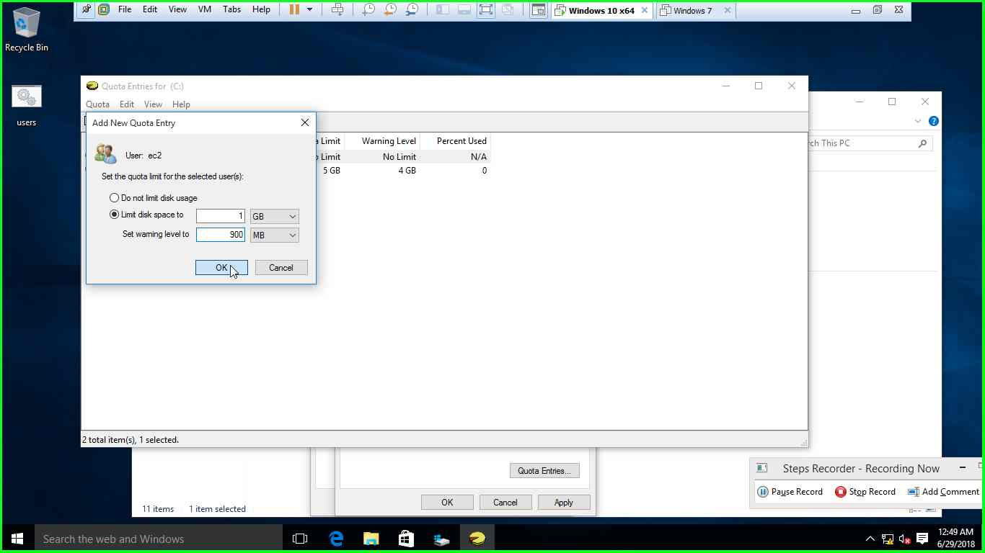

Enable disk quota of 1MB for a new user  
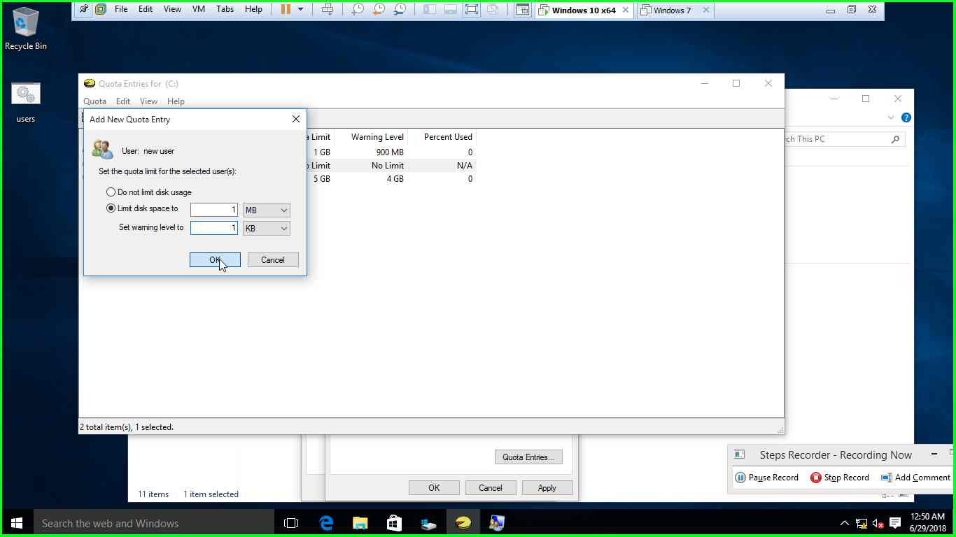

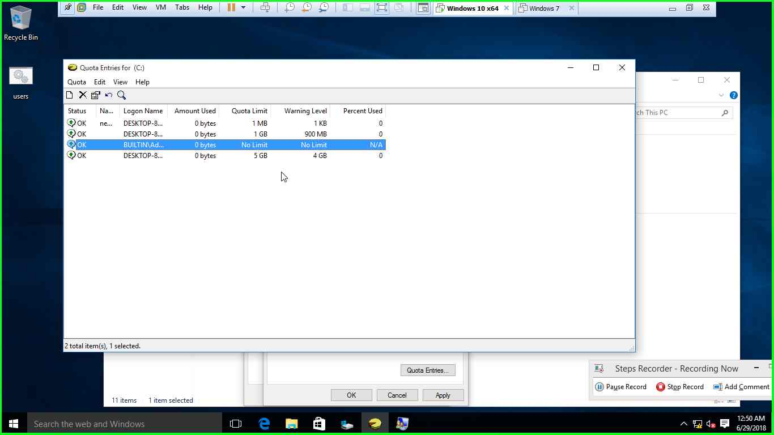

11)create a folder on a NTFS drive and enable encryption from EC6 and also access permission is given to EC8

